# Day-1 (17-07-24)

[Spring Boot Tutorial - Learn Spring Boot (geeksforgeeks.org)](https://www.geeksforgeeks.org/spring-boot/)(

Imp Link:- [Spring Framework Documentation :: Spring Framework](https://docs.spring.io/spring-framework/reference/index.html)

[20+ Spring Boot Projects with Code Examples | Spring Boot Tutorial](https://www.springboottutorial.com/spring-boot-projects-with-code-examples)

[A Comparison Between Spring and Spring Boot | Baeldung](https://www.baeldung.com/spring-vs-spring-boot)

1) def's

2) linux

3) os

do certications java(smpg) ibm

youtube:- spring1 ...videos on spring from creators

Goal before the end of training:- Host a website

things required to build an app

1) vision ..on what to make what are the functionalities

2) Goal...whether it should handle large number of people or should solve ur purpose

3) Skill

4) Storage

5) front end

6) back end

7) storage

8) server

Iaas,Paas,Saas,on-site

***task:- types of servers ? what are there configurations?***

***how software is converted to an image? ...how virtualizations works***

----------------------------------------------------

public class Phone{

int number;

char letter;

int storage;

int megaPixel;

String regulations;

String instrctions;

float version;

String phoneName,userName;

}

public class Perfume{

String perfumeName;

int quantity;

int noOfSprays;

int mrp;

date expiry;

String companyName;

}

public class Diamond{

int price;

String diamondName;

String shape;

***task: create a "diamond" class ...inheritance kind off***

#in java we use methods not functions

keywords:

1. instanceOf

2. throws

3. transient

4. default - used in 1) switch cases 2) creating methods(default methods in java functional interface)

5. public class

6. synchronized - Mutex(in os)

paas...used by startups

iaas ....devops people....those who have experminedted on theri website and know what is the problem in there webitse

saas…salesforce,canva etc

**MICROSERVICES:**

1. **Monolithic architecture(Ex:- SAP software and ERP)**

**It is a large code ..**

*Limitations of monolith:*

1. Difficult to integrate. (Changes at one can affect other)
2. Not easy to scale. (Scalability:- As the number of people increases the performance should also scale)…Scaling is of two types: Horizontal and vertical scaling
3. Not easy to upgrade
4. **SOA(Service oriented architecture):**

**Above diagram is vvvvvimp…learn and understand it perfectly …must be able to explain**

**Interoperability:- ability of systems to communication with each other**

SOA principles are realized or implemented using webservices(Amazon aws etc )(Same like java and oops ..java is a language which supports the oops concepts)

Two types of webservices:

1. SOAP(Simple object access protocol) based
2. RESTbased services

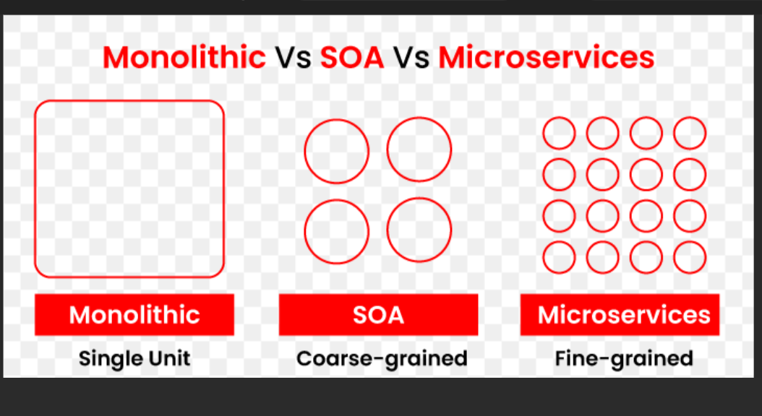

**Task: install sts4.x or latest**

**Jdk 21**

**Maven 3.x**

Eclipse ide for enterprise java and web developers version:- 2023-09(4.29.0)

Build id:- 20230907-1323

Environment variable setup:

; is for appending

CLASSPATH is the path which have the dependencies of a folder

A.java is compiled and saved in (for example .. E:\Temp\)

Now go to new drive and create a file with main method and the method calling in A.java

Now in cmd …(only possible in cmd ) and type the following

set classpath=%CLASSPATH%; E:\Temp;

Now press javac B.java

Now if u want a skeleton of all the available methods just type…

Javap java.util.ArrayList;

This is called as decompiler

We use this for

Javap -c A.class

This will show a assembly language code

# DAY-2(18/07/24):

**Create a store which deals with eggs(do in arraylist),milk(hashset),chocolates(**

**linkedlist),apples on treeset, bread (on queue)**

**And also put all the above in the hashmap<Integer,Collection>**

**They will write a query and should get the output**

Public class Milk{

Int quantity;

date expiryDate;

String companyName;

String type;

Milk(int quantity, date expiryDate, String companyName, String type){

this.quantity=quantity;

this.expiryDate=expiryDate;

this.companyName=companyName;

this.type=type;

}

}

Public class Eggs{

Int quantity;

String companyName;

Date lastDateOfConsumption;

Eggs(Int quantity, String companyName, String lastDateOfConsumption){

this.quantity=quantity;

this.companyName=companyName;

this.lastDateOfConsumption= lastDateOfConsumption;

}

}

public class Chocoloates{

String companyName;

Int quantity;

Int price;

Chocolates(String companyName, Int quantity, Int price)

{

this.companyName=companyName;

this.quantity=quantity;

this.price=price;

}

}

public class Apples{

int quantity;

String placeOfOrigin;

Int price;

Apples(int quantity,String placeOfOrigin,Int price){

this.quantity=quantity;

this.placeOfOrigin=placeOfOrigin;

this.price=price;

}  
}

public class Bread{

int quantity;

String type;

Date dateOfExpiry;

Bread(int quantity,String type,Date dateOfExpiry){  
this.quantity=quantity;

this.type=type;

this.dateOfExpiry=dateOfExpiry;

}

}

public class Store{

Scanner sc=new Scanner(System.in);

ArrayList<Integer> eggs=new ArrayList<Integer>;

HashSet<Object> milk=new HashSet<>;

LinkedList<> cc=new LinkedList<>;

TreeSet<> app=new TreeSet<>;

Queue<> breadQueue = new Queue<>;

HashMap<Integer,Collection> all=new HashMap<>;

Public ArrayList addEggs(){

Eggs eg1=new Eggs(12, Venkateshwara Hatcheries Limited, 20/07/2024);

Eggs eg2 = new Eggs(10, "Eggcellent Farms", "21/07/2024");

Eggs eg3 = new Eggs(15, "Golden Eggs", "22/07/2024");

Eggs eg4 = new Eggs(8, "Sunrise Poultry", "23/07/2024");

Eggs eg5 = new Eggs(6, "Rocky Mountain Eggs", "24/07/2024");

Eggs eg6 = new Eggs(9, "Northern Nest", "25/07/2024");

eggs.add(eg1);

eggs.add(eg2);

eggs.add(eg3);

eggs.add(eg4);

eggs.add(eg5);

eggs.add(eg6);

return eggs;

}

public HashSet<> addMilk(){

Milk m1=new Milk(2,”20/07/2024”,Amul,tetrapack);

Milk m2 = new Milk(1, "21/07/2024", "Nestle", "glass bottle");

Milk m3 = new Milk(3, "22/07/2024", "Dairyland", "carton");

Milk m4 = new Milk(2, "23/07/2024", "Organic Valley", "glass bottle");

Milk m5 = new Milk(4, "24/07/2024", "Nestle", "plastic jug");

Milk m6 = new Milk(1, "25/07/2024", "Horizon Organic", "carton");

Milk m7 = new Milk(3, "26/07/2024", "Amul", "bottle");

Milk m8 = new Milk(2, "27/07/2024", "Nestle", "tetrapack");

Milk m9 = new Milk(1, "28/07/2024", "Promised Land", "glass bottle");

Milk m10=new Milk(0.5,”28/07/2024”,”Amul”,”glass bottle”);

milk.add(m1);

milk.add(m2);

milk.add(m3);

milk.add(m4);

milk.add(m5);

milk.add(m6);

milk.add(m7);

milk.add(m8);

milk.add(m9);

milk.add(m10);

return milk;

}

public LinkedList<> addChocolates(){

Chocolates c1 = new Chocolates("MilkyBar", 10, 5);

Chocolates c2 = new Chocolates("Hershey's", 8, 4);

Chocolates c3 = new Chocolates("5star", 12, 6);

Chocolates c4 = new Chocolates("Ferrero Rocher", 15, 8);

Chocolates c5 = new Chocolates("Eclairs", 20, 10);

Chocolates c6 = new Chocolates("Nestle", 5, 2);

Chocolates c7 = new Chocolates("Mars", 6, 3);

Chocolates c8 = new Chocolates("Kismi", 7, 3);

Chocolates c9 = new Chocolates("Alphalebe", 5, 4);

Chocolates c10 = new Chocolates("Milka", 8, 3);

cc.add(c1);

cc.add(c2);

cc.add(c3);

cc.add(c4);

cc.add(c5);

cc.add(c6);

cc.add(c7);

cc.add(c8);

cc.add(c9);

cc.add(c10);

return cc;

}

Public TreeSet<> addApples(){

app.add(new Apples(24, "Nagpur", 30));

app.add(new Apples(20, "Shimla", 35));

app.add(new Apples(18, "Kashmir", 40));

app.add(new Apples(22, "Himachal Pradesh", 32));

app.add(new Apples(25, "Kinnaur", 38));

app.add(new Apples(28, "Uttarakhand", 36));

app.add(new Apples(30, "Jammu", 34));

app.add(new Apples(26, "Arunachal Pradesh", 37));

app.add(new Apples(21, "Sikkim", 33));

app.add(new Apples(23, "Meghalaya", 31));

return app;

}

Public Queue<> addBread(){

breadQueue.add(new Bread(5, "Whole Wheat", new Date(2024, 7, 20)));

breadQueue.add(new Bread(3, "Multigrain", new Date(2024, 7, 22)));

breadQueue.add(new Bread(4, "Sourdough", new Date(2024, 7, 25)));

breadQueue.add(new Bread(6, "Rye", new Date(2024, 7, 18)));

breadQueue.add(new Bread(2, "Baguette", new Date(2024, 7, 21)));

breadQueue.add(new Bread(7, "Ciabatta", new Date(2024, 7, 24)));

breadQueue.add(new Bread(5, "Pumpernickel", new Date(2024, 7, 23)));

breadQueue.add(new Bread(4, "Focaccia", new Date(2024, 7, 19)));

breadQueue.add(new Bread(3, "Naan", new Date(2024, 7, 26)));

breadQueue.add(new Bread(5, "Pita", new Date(2024, 7, 27)));

return breadQueue;

}

**Inside beans.xml**

<bean name=”countyEgg” class=”com.ust.product.Egg”>

#Create a reference or instance f the class …bacially Egg countyEgg=new Egg();

#now to pass or assigne values we use constructor-org

<constructor-org name=”quantity” value=20></constructor-org>

#basically the constructor creation and assigning values

<constructor-org name=” dateOfExpiration” value=24/07/2024></constructor-org>

</bean>

Oops=objects pull object dependencies

IOC=objects meet the dependencies through push mechanism(only two..constructor and setter)(That’s why we say constructor and setter injection)(In IOC only these two..in spring boot property injection is also added)

**How to write the Arraylist etc in beans.xml ..why ? because we donot want that to be created inside our code and add elements..tight coupling**

<bean name=”countyEgg” class=”com.ust.products.Egg”>

<constructor-arg name=”id” value=”101” > </constructor-arg>

<constructor-arg name=”description” value=”Heritage” > </constructor-arg>

<constructor-arg name=”quantity” value=”25” > </constructor-arg>

</bean>

<bean name=”countyEgg1” class=”com.ust.products.Egg”> #here the name represents the object name created

<constructor-arg name=”id” value=”102” > </constructor-arg>

<constructor-arg name=”description” value=”Amul” > </constructor-arg>#here the name tag represents the variable name required by the class

<constructor-arg name=”quantity” value=”05” > </constructor-arg>

</bean>

#Main code for the question is below …till now created two classes and now we are adding thme

<bean name=”eggList” class=”java.util.ArrayList”>

<constructor-arg>

<list>

<ref bean=”countyEgg”/>

<ref bean=”countyEgg1”/>

</list>

</constructor-arg>

</bean>

* **Features of spring …dependency management and non invasive(donot change every line of code) …also spring is a framework not language ..i.e helps in building on top.(i.e amixture of ready made codes which are ready to utilise)**

**TWO TYPES OF INJECTIONS(i.e spring supports two dependencies ..constructor and setter)**

**Number-1 Constructor Injection**

<bean name=”countyEgg1” class=”com.ust.products.Egg”>

#here the name represents the object name created

<constructor-arg name=”id” value=”102” > </constructor-arg>

<constructor-arg name=”description” value=”Amul” > </constructor-arg>

#here the name tag represents the variable name required by the class

<constructor-arg name=”quantity” value=”05” > </constructor-arg>

</bean>

**Number-2 Setter Injection**

<bean name=”countyEgg1” class=”com.ust.products.Egg”>

<property name=”id” value=”102” > </property>

<property name=”description” value=”Amul” > </property>

<property name=”quantity” value=”05” > </property>

</bean>

* **We need to tell our java compiler to create an IOC container and handle our beans and dependencies.**Therefore in mian method in new file we write this

ClassPathXmlApplicationContext context=new ClassPathXmlApplicationContext(“beans.xml”);

From now on we should not write System.out.println()..we should write console.log…

**Task:- java.util.log …learn how to use log to print …instead of system.out.println**

# MAVEN

**Maven consists of all the best practises to create a software . If u don’t know maven we cannot go to real time projects. Maven is the plugin execution system. It is also a best practises tool.One of the ultimate reason or goal is to create a professional .jar file.**

**IN CMD write this *:-*** *maven archetype:generate* …will help us to create a project skeleton in an interactive way

Type a number given or u r own or just press enter

**groupId:-** company name (IG)

**artifactId:-** what exactly the functionalities are contained(people are going to look here )

**SNAPSHOT:-** development under process….every s/w will start from here only

**“tree/f”** (not tree or f but both with a /) ..will show u directory folders in flowchart manner

We wont have all the libraries in enterprise java like normal java…we need to download the jars(java archives …later there was no need of downloading also …we just need to write the code..there u see search only the groups or artifacts etc ..thats the importance of groupid and artifactid

**mvnrepository.com**

type spring and select spring core first …generally we search inside spring docs which should be taken ..but for now take only the spring core and v4.0.0 ………….after all the dependencies are pasted press ctrl + s…u will see .jar files will be downloaded at left side .

press **alt+shift+s or ctrl + 1** **or right click ..find source and check in it ..**to get the option of generating toString,getters and setters ,constructors

# DAY-3(19/07/2024)

[Bean life cycle(init,destroy..ig),autowire,

Did one more spring project ..shapes(rectangle triangle )

In oops …

class ->(classes are created to create )Objects

Objects -> (initialise the properties using ) Constructors

After this methods are executed

Which are in class

Class -> Object

| (Up) | (Down wards arrow)

Methods <- Constructor

These above are the four main important pillars …must and should learn each

Data==properties==state

Behaviour==methods

._> factory , then that means object creation …which mostly involves static

* When ever we are using getter and setter injection it is very important to use the default or empty constructor to avoid problems

# Logger(Replacement of Sys.out)

**-> We cannot use Sys.out..it will be deleted or commented in production or before production. Therefore we use logger …it will also help in debugging ..we cannot write sys.out since it wont pass 15 gates of quality production.**

**-> To make logger not show any output we can do that in application.properties**

**->With logger we need to use string or toString ..i.e …using logger.info(s1+””) or logger.info(s1.toString())**

**-> Logger gives output in red colour with date and time**

In entire spring only two containers…BeanFactory or Application context(vvvvvimp)

Bean factory can only create objects and manage life cycle…it is very basic ..application context has wide features and came after bean factory. For both of these the scope named tag is important.

isSingleton,singleton,scope,and prototype in spring …find?

Singleton…assigns same reference for every object (obj1==obj2 #True)

Prototype ..assigns different reference for every time object created (obj1==obj2 #False)

Component vs object in software

Components are …a group of classes ….a feature ….

Objects ….created after classes…only delas with fucntiocnal requirements

Flow: first jvm is started then main method then object is created then constructor is used THEN the init method is used because we need some splecial properties .

**AUTOWIRED:**

It have three varieties …1) by name 2) by type 3) constructor

**Lazy loading and eager loading in spring …lazy init and early init**

* In bean factory beans are lazy loaded
* In application context single ton beans are eagerly loaded

All xml files are broadly used as configuration files

# Day-4(20-07-24):

**{Taught/files/codes:- Annotations…codes: annotationsjavaconfig,mobi-sim etc,**

Till now we were creating individual independent beans and referring them below inside xml file like <constructor-arg><ref bean=”a1”/> …but we can directly create inside only but cant access using getBean(“”) ..search what we can use for this …

The method which we can use …<contructor-arg><bean></bean></contructor-arg>

Links:

1. https://docs.spring.io/spring-framework/docs/current/javadoc-api/org/springframework/beans/factory/BeanFactory.html
2. [Lazy-initialized Beans :: Spring Framework](https://docs.spring.io/spring-framework/reference/core/beans/dependencies/factory-lazy-init.html)
3. [Container Extension Points :: Spring Framework](https://docs.spring.io/spring-framework/reference/core/beans/factory-extension.html#beans-factory-extension-bpp-examples-aabpp)
4. **@Autowired…there is dependency or other file class / variable something is required**
5. **@Component…means that this can be used by other files**
6. **@Qualifier…..**
7. **@Primary…first this will get executed**
8. **@Service…this will hide the layer …hide the business or important logic ..or abstarcts data access layer from other layers**
9. **@ComponentScan…….scans where are all the components are presenst inside a package**
10. **@Configuration…denotes that it is a configuration class**
11. **@PropertySource….tells the source or file name of the application.properties file**
12. **@Bean(name=””) …creates a bean to send the values**
13. **@Value(${variable_name})…this can be used only in the instance level ..that is inside a class and outside the methods**
14. **@PostConstruct**
15. **@PreDestroy**
16. **@Service**

* **AutoConfig is the file where all the data access and injections happen**

# Day-5(22-07-24)( Few more annotations , REST)

* **@Controller ….**used on top of MVC Controller classes

(Learn JSP and servelets) (in 1 week )

* In bean factory …beans are loaded lazily ..in application context beans are loaded eagerly
* **@DependsOn**…bean on which this bean depends to be created before the bean is created.
* **@Scope(“prototype”) …if not mentioned it is by default singleton**
* **@Lookup…**indictes a method as a lookup method it is best used for injecting a prototype-scoped bean into a singleton bean.
* **Configuration annotations…**
  + **@ComponentScan…**
  + **@Configuartion(always about java configuration )**
  + **@Profile…Dev,Test,Prod**
  + **@Import({JpaConfig.class,SchedulerConfig.class})**
  + **@ImportResource({“spring-context.xml”})**

REST (Representational State Transfer) Full Services or REST API: (Created by Roy Fielding)

Links:

* [Learn REST API Design - REST API Tutorial](https://www.restapitutorial.com/)
* [Java Software | Oracle](https://www.oracle.com/java/) (vvvvvvimp ….webpage)

HTTP is a state less …If we want state we go for SOAP if not we go for REST

There are about 9 methods in HTTP(get,post,delete,put etc..these r common 4)

SOAP always required to know about interface before invoking services

REST is like using HTTP success principles to be used in creating the enterprise java application

* For app to app communication rest is best …
* for customer to business etc etc communication we use SOAP(Simple Object Access Protocol(SOAP) )

Maven By default build or uses jar packaging ….war is web archive used for creating websites

**Soring supports 3 types of packaging …jar,war,pom…spring boot supports only two war and jar**

Spring Boot = Spring – (minus)configuration files(beans.xml) + AutoConfiguartion + starters + Actuators +Dev Tools +Cloud Tools + CLI

Spring boot= 10 years of spring experience -DRY(Donot repeat ur self)

**It is not a replacement of spring we are doing spring using spring boot(like java using eclipse)**

Spring boot = promotes Agile Development + Dependencies are automatically added through starters + Inbuilt tomcat server + one InMemory database called H2 database.

Spring boot – Microservices(Without microservices spring boot dies) -> microservices need Restful

**In spring boot all java files should be in java folder**

**Html,css etc in the resources folder**

**Target folder is very important ..we need to keep it updated,clean etc**

**mvnw..is to use for creating maven projects**

**pom.xml is to add dependencies …every pom is a sub pom like all classes are child classes of object class**

**actuators are available inside the org.springframework.groupid (I guess)**

**if we have dev tools in our project we don’t need to start the tom cat server again again …directly we can close and open or change the files again again (Like liveServer in vs code)**

**REST will help our java files to be accessible from anywhere in the world(not the file but the outputs)**

**@GetMapping…**Used as a designator so that when a resource comes it can handle the request

**API -> API is the new way wrapping the code…basically helps in making our own library kind of thing ..java.lang is a api etc**

**//API …when building api u r building endpoints**

**//Endpoint… when building Endpoint u r building handler**

**//Handler.. when building handlers u r building specific handlers to carry one specific task**

**@RestController…**Controller+ResponseBody -<body>,http headers, In http headers

other then get we will have body too…(pay load).

We can send or write into response body using ResponseEntity class

**@Controller** -> commit or render views using view technologies(mostly html or jsp or tiles or veleocity) …what is to be shown to the user or customer

With REST we use json so that the documents can exchange easily …in soap we use xml only for everything(this is what payload I guess).

**@GetMapping** -> Handler Resource for HTTP GET request

Taking input using get method:(ways)

1. query string (i.e ?name=value is there then it Is a query string) ..sent via request url)
2. Main url followed by a forward slash(/)

@PathVariable to receive this input and use in the method

@GetMapping

@RequestMapping(“/{gender}”)

Public String genderMessgae(@PathVariable String gender){}…And in url keep **localhost:8080/male**

1. the varible gender should be same in both method parameter and here in side curly braces or else wont work
2. We can take any number of inputs

@GetMapping

@RequestMapping(“/{name}/{gender}”)…just separate by / and keep individual @PathVarible inside the method

Public String getMessgae(@PathVariable String gender,@PathVariable String name){}

In url **localhost:8080/Kausthub/male**

1. If there are two direct value taking func ..it will give error ..example

@GetMapping

@RequestMapping(“/{gender}”)

Public String genderMessgae(@PathVariable String gender){}…

@GetMapping

@RequestMapping(“/{age}”)

Public String ageMesssage(@PathVariable int age){}…

Even though data types and variables are different still it gives errors(ambuiguity)

**@PostMapping** -> Handler Resource for POST requests

**@PutMapping** -> Handler for PUT request

**@DeleteMapping**-> Handling HTTP delete

**@RequestMapping** -> same as GetMapping but point is we cant use GetMapping for two r more methods in the same class …ambuiguity in what to take …for thos we use Requestmapping along with Getmapping

In entire http and world wide web the default is GET . In postman we specify post or get but in browser we don’t do that ..since by default it is get only

For every file u create change the @RequestMapping url which is at the start of the file

*Important point ….<> is called diamod operator …and in left side only we need to mention the datatype no need on right side..Since it was becoming redundant the new java versions remoebvd them*

*Example*

*ResponseEntity<String> rp=new ResponseEntity<>()*

**Lombok Important steps to follow**

**Lombok Dependecy (research)…we need to download the jar separately then click on executable java file ..then select the spring tools suite (browse…just specify the final location..the one which has the green colour icon spring tools inside foderor eclipse or one after the other ..then close the spring tools and open alog with plugins readme folders etc**

**POST METHOD IMPORATNT STEPS TO FOLLOW**

**When using POST method ..in postman we need to create a new request that is press + at left top then change to POST and paste the url after that go to body ..change to json ..and send the values ..with appropriate already given no typos variable names and there values like this**

**{**

**“name” : “John Doe”,**

**“gender”:”male”**

**}**

In professional life we wont write return string etc ..we return obj(iguess) here we return ..we should return …ResponseEntity… When ever we are talking about header..we talk about key value pair..iN fact entire web is key value only

*Client (definition of clients)-> end user-> Browser(user-agent, proxy)->application and server communication through HTTp headers – request and response headers.The most common headers are content_type,etc etc*

HTTP status codes…1xx,2xx,3xx,4xx,5xx

Now most important part of the entire project …creating a jar file…

U will see that our target folder is empty …

Now we will build a jar file

Right click on the entire PROJECT(top left )

Then click on run as …followed by maven clean…followed by maven install

If cant see press maven clean ..followed by maven install ….u will see a jar file in the target folder

After that again right click on entire project…u will see “show in local”…then terminal(basically open local terminal)

Type **java -jar target\<filename.jar> ..without brackets**

**Mvn clean will delete the target folder contents …so that we can start fresh**

**After that when we press maven install …it will undergo phases to check if everything is according to the best practices or not**

**U can check in some m2 folder (research where exactly)**

# DAY-6(23-07-24)

Autowire ,Autowired,autoconfiguration …all are three different words..one is annotation,one is beans.xml tag ..other is ?(Search for these three words)(Also search what is stereotype)

**@SpringBootApplication…is a combination of 3 annotations(@ComponentScan,@SpringBootComfiguration,@EnableAutoConfiguration)**

**…It scans the classes present inside only in that package**

**Very Important Note:-**

* The code scans the root package which is here com.ust.store….so if u want u r code to execute …make sure u keep ur services repository entity inside the same package ….But when u see it wont be like sub sub package ….like package inside package …  
  Now the file names should be

com.ust.shop.entity

Com.ust.shop.controller

Com.ust.shop.service

* Even in spring tool suite ..u will see like this only ….not like click the com.ust.shop inside com.ust.shop.controller ..not like that
* **Also make sure any where in the world…the package name should not have any capital letter at all**

If any problems or more information ..go to **meta inf** ..which is in the **spring boot auto configuration 3.3.2** which is in **maven** dependencies

The word hook is the new term for callback…the term shutdownhook is doesnot letting the jvm to shutdown before the lifecycle gets completed

Learn lifecycle(some 14steps …last second step is init)…very very important for interviews

**When we changed from xml configuration to annotation configuration we used context(Application context)**

Synchronous communication means when one sends or speaks other listens …(i.e one is blocked)

Commands to be used in command line :

**mvn spring-boot:run** (if maven is there in system)

**.\mvnw spring-boot:run** (if there is no maven in the system)

Spring 1) has their own web framework 2) supports others frameworks 3) manages others frameworks

javaE requires extending every method else it wont start….whereas spring is not invasive so therefore it doesnot need extending any method

pojo==plain old java object

Very Important book and certification .. **head first servlets and jsp pdf (Already downloaded the book)**

**Changing the final name of the jar file using <finalName> tag in the pom.xml before <build>**

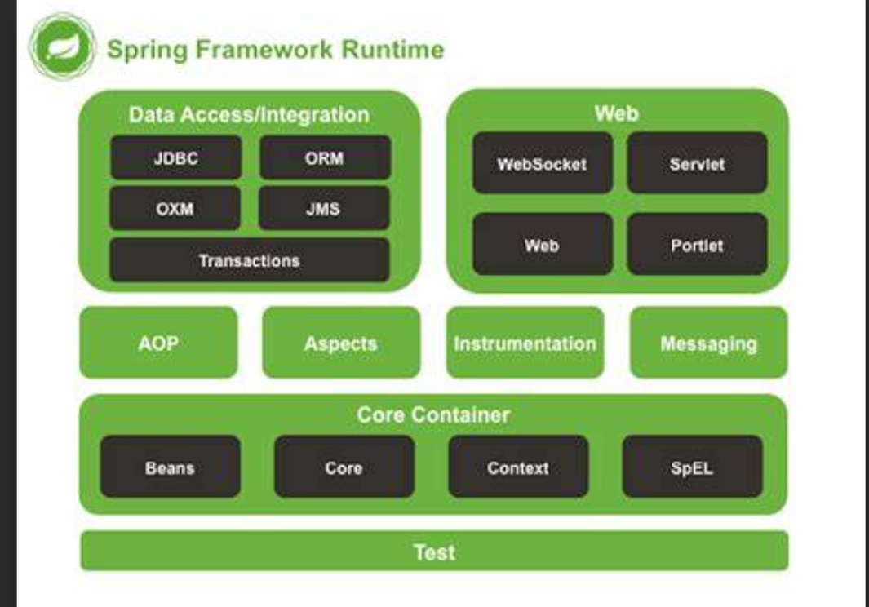

EJB=Enterprise java bean

EJB container…helps in taking data from the database(I guess) ..not popular but in banks still used

ORM…

Object cannot be pushed into an database (since both evolved in different generations…or object is a graph kind of key value thing…where as database are rows)

So these ORM try to fill the gap so that java developers no need to write sql code and no sql code in java. ORM Creates a virtual object database.

**Persistance or persist in pogramming …is writing a file or database or storing into database** (Max..storing)

ORM impedence mismatch

Hibernate ORM was created by gavin king

**Software layered architecture**(above picture)…each layer might be residing in different servers at different layers…as a full stack u will be working in business layer or business logic(might be).U cant write code of one layer into another

In code we have written controllers…controllers or resources are both the same…therefore com.iiht.restjpa.controllers or com.iiht.restjpa.resources both are same  
“””Spring Annotation…Hibernate Annotations…JSR annotations”””

# JPA

Extends JpaRepository<Product,Long> why long..since primary key …we should keep primary key datatype

Second level cache is by default closed…what is first levelcache search?

We use spring.jpa.hibernate.ddl-auto=**create**…to create the table if not exists(actually if table doesnot exist …it will create but sometimes it wont work for those write this in application.properties)

We will also have many options like update etc Once u used create and created a table …then automatically change the word to update …or else every time u insert the table gets created new and u will see only one row

If we give table name or column name in camel case….it will change into the snake case (that is uses underscore) (productTable <-> product_table) (columnName<-> column_name)…and vice versa

U will have multiple databases…in which if we want to use one database ..we will write [jdbc:mysql://localhost:3306/test... (where](https://localhost:8891/test...%20(where) test is the database name (any name))

**Donot forget to change the PUT**(when wants to **update** the values)**,GET(**When want to **fetch** values),**POST(When want to insert values),DELETE in the postman…also donot forget to use Body option present just below to send json ..when u want to send all values without using url**

VVVImp Link for Application.properties (Contains everything)

[Common Application Properties :: Spring Boot](https://docs.spring.io/spring-boot/appendix/application-properties/index.html)

Spring supports jar and war and **builds or packaging**

**Maven supports jar war and pom builds or packaging**

What do u mean by retention ..

What do you mean by scope in maven …till how much time the jars are available (only during execution or during testing also etc etc )…learn about maven scopes(runtime ,import etc)

**Working with H2 database:**

Remove the my sql jpa and my sql connector dependencies

Remove the content in application.properties

Inside that set the port number

No run spring boot application..

U will find a url kind of thing at the left side of the console and copy that (u will find url=jdbc:h2:mem:….)( no need of user:SA)

Now in browser ..type **localhost:<portnumber>/h2-console**

In that paste this url and click on connect..u will see this

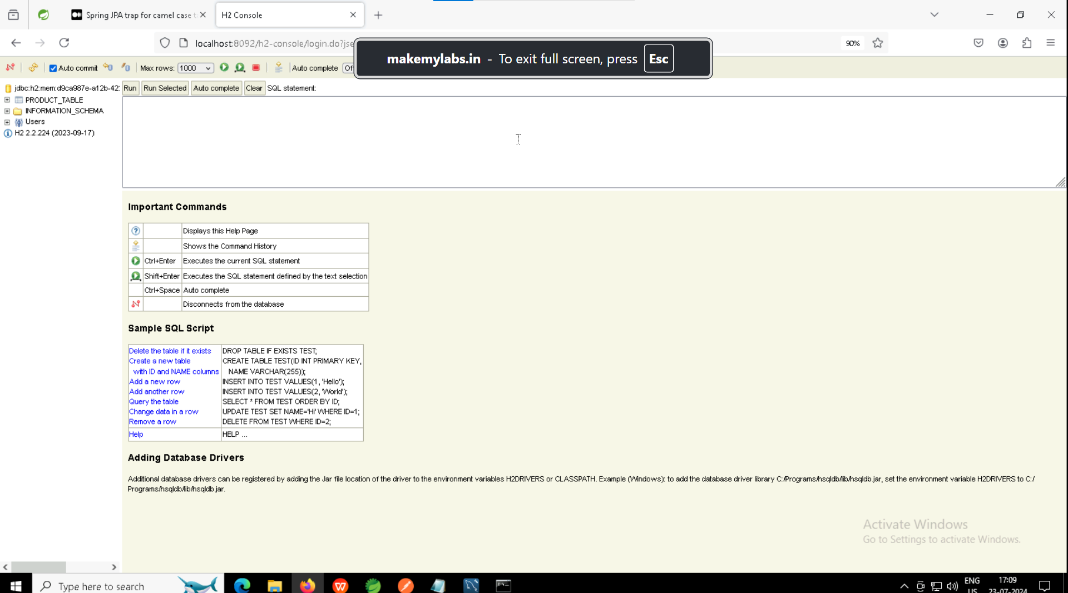

# DAY-7(24-07-24)

To be covered:-

1. Profiles
2. Swagger
3. Actuators
4. Start on microservices
5. Exception (when should we use throws vs throw …how to handle the exceptions in spring)

**In spring.jpa.hibernate.ddl-auto=create or update**

The difference between **update** and **create** is that …for create when ever we re run the code the table gets created again and all our previous values are lost .where as update is that it creates and updates in the table only not create new every time we re run ….btw create and update are only for schema or table structure not for rows or values…­­

AOP is a technology which can monitor the code and can add functionalities which are in all other codes

**Exception Handling in spring boot:**

We cannot use print as we wont be using console..anything should be there in browser only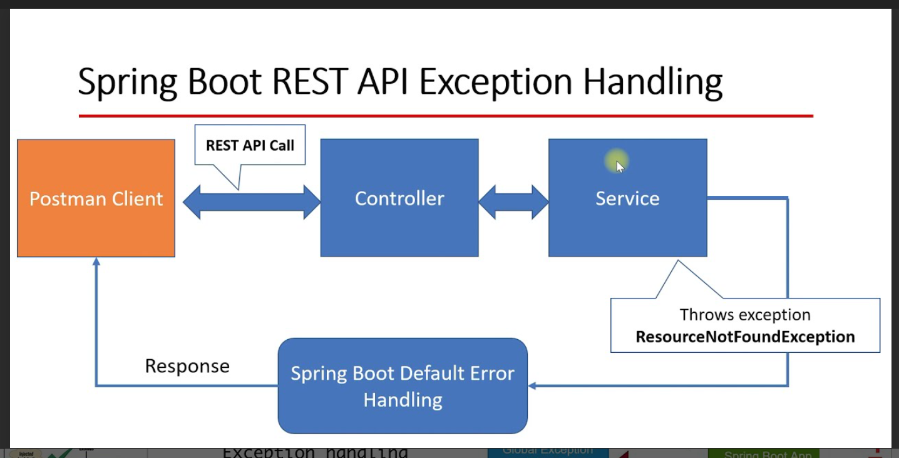

Runtime exceptions are not that dangers..as we can write some defensive code

Checked exceptions should not be visible to client

Every exception should have its own handler to be written

There are no catch blocks..instead we have handlers …we should use them

@ExceptionHandler

@RestControllerAdvice[Combination of restcontroller(combination ofrest and response body) and advice]

**SWAGGER(To see type localhost:<portnumber>/swagger-ui/index.html)(Also make sure to runn the code)**

**Makes rest simple for users…no need of postman(Replacement of postman…contains all the api’s / endpoints which we created in the code )**

**Actuators(vvvvimp…how to see them how to add/remove them etc etc)**

Actuataors are the thing which populates and takes the spring boot application information

**Endpoints:**

Every Method we are defining in REST is an endpoint(since above method we will have Get/Post/delete/put/request mapping. Basically those who process the user request.

**Profiles-(Dev,Test,Prod):- (compulsory read.. used in real life s/w development)**

It is all about application.properties…..

application-dev.properties

application-test.properties

application-prod.properties

these file will be used instead of application.properties

* Status=UP means that the process is running ..not heating up

Commands to execute profiles in terminal

mvnw spring-boot:run -Dspring.profiles.active=dev

mvn spring-boot:run -Dspring-boot.run.profiles=dev,foo,bar (dev,foo,bar all are profiles only)

@Profile(“dev”) it will be creating only those beans required by the dev profile

**MICROSERVICES:**

ImpLink:

1. [GitHub - Book-Microservices-v2/chapter03: Learn Microservices with Spring Boot (2nd edition) - Chapter 3](https://github.com/Book-Microservices-v2/chapter03)
2. [GitHub - PacktPublishing/Microservices-with-Spring-Boot-and-Spring-Cloud-Third-Edition: Microservices with Spring Boot and Spring Cloud, Third Edition](https://github.com/PacktPublishing/Microservices-with-Spring-Boot-and-Spring-Cloud-Third-Edition)

We will be developing restful services when talked about microservices …there fore rest and microservices are not same…multiple services can be created in multiple languages..no need of only one language ..can create with many …..since we need only json and header

API gateway is also known as **edge service** It will also perform :-

1. Load balancing
2. Security(if gateway says ..request cant enter… it wont allow)

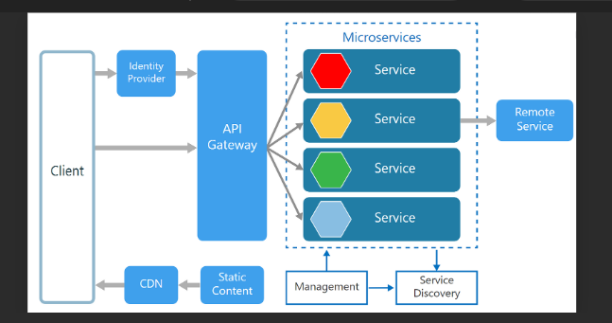

Microservice infrastucture

Service discovery is like it will have information about every service …for a request .it will see whether a service is registered for that or not and return service or else exception

Services location is transparent ..this is done by api gateway and service discovery

What are all the services provides and how to configure them(only using application.properties) (This is vey important before any project)

The purpose of config is to externalize the ..?

* Every service is a spring boot application/….for a base project of only 1 service …we should do 4 spring boot application( 1 service , 1 api gateway, 1 client 1service discovery)

The port number of registry service should be 8761…the service port number can be anything.

There are two containers in spring

1. Beans
2. Application Context

# DAY-8(25-07-24)

Links:

1. [Spring Cloud Gateway](https://spring.io/projects/spring-cloud-gateway)
2. [Spring Cloud Gateway](https://docs.spring.io/spring-cloud-gateway/docs/current/reference/html/) (Different Links)
3. [Getting Started | Building a Gateway (spring.io)](https://spring.io/guides/gs/gateway) (Best ones…if u just click “guides” u will get guides for rest also …like that may guides ar available)
4. [The Twelve-Factor App (12factor.net)](https://12factor.net/) (VVVVimp…all the 12 features should be there in the microservices )
5. [Spring Cloud OpenFeign](https://spring.io/projects/spring-cloud-openfeign)

Things will be taught:

1. Cloud Gateway
2. Cloud config
3. OpenFiegn
4. Circuit breakers

Localhost:8761 …to check all registered with eureka …we get all the class names which is using eurekaRegistryService….i.e they are getting registered to ureka discovery client..hat means….the eurekaRegistryService will be acting as **service discovery** which will have all the services been provided.The client or outsid services wont get registered …it is our internal services only get registered



**Ports(Fix these ports or remember them for ever)(All files should be there)**

1. Registry: 8761
2. HelloService:8071
3. HelloClient: 8072
4. Gateway: 8070

Don’t forget to keep either eureka discovery client or eureka server in dependencies..it depends which one

# Cloud Gateway:

eurekaRegistryService project is also used and runned..after that helloGateway is runned

Add “**Reactive gateway** from pom…why not normal gateway because ..it is giving mvc gatway in the dependency ..the mvc should not be there”

<repository>

<id> spring -milestone</id>

….

Not there anywhere on web …so copy paste from pom.xml of “helloGateway” project

If any mistake there in yaml file…go and check in **yaml lint** website

Uri …is same as url only but t doesnot promise any resource

**To check actuators ..add the depdnecy using right click on project ->spring boot-> add starter file-> actuator …and which ever actuator u want to see ..add the port number of that project followed/actuator.**

* **Donot write header after making request ..it wont get to http or write header after response**

Routes as three attricbites:

1. Id

We will be using “Fluent” for which we use STREAMS…there is also a term called domain specific language(DSL)(Always break or go to next line after dot(.) for readablility)

Builder,fluent api,streams,domain specif language

# Cloud Config:

This will redirect to github (may be) and install all the dependencies or configuration

* RestTemplate is an important thing to access our api’s..There is also an alternative t RestTemplate ..i.e called openFiege

[All coding starts from Entity…the client needs that …we store that in database…it performs ..data abstraction or representation]

# Open Feigne

[Feign (readme.io)](https://resilience4j.readme.io/docs/feign)(might help)

# Day-9(26-07-24)

Todays codes…

1. Added resilience4j in the Feign Client

Todays topics …

1. Circuit breaker intro
2. Gateway load balancing
3. sleuth

**Circuit Breaker design pattern or circuit breaker microservice**

Equivalent to exceptions and multi-threading in java

Circuit breaker is a microservice which monitors the calls..the moment the response not comes from services …it will immediately opens the circuit breaker…which will go to its life cycle…i.e when will it restore so that the communication goes on.

Sometimes we see connection timed out…i.e systems cant wait indefinitely to communicate with other system…it will redirect the request back to the user again if it feels there is no communication or connection with other system.

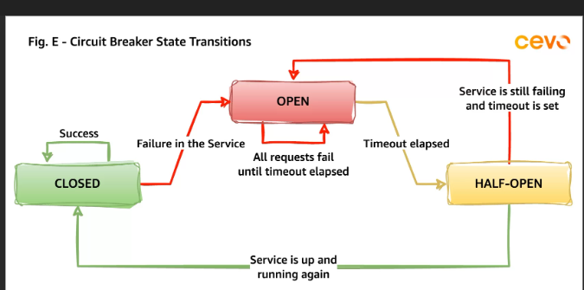

**Load Balancing:**

To distribute the load evenly ….we create few instances of same service immediately …this immediately is possible only because of microservices not monolith because monolith takes times to load and create instance …

To demonstrate this we are creating and EUREAKAREGISTRYSERVICE(fresh ones) ..then create a micro service ..register to eurekaregistryservice ….the create a gateway ..then reister to eureka registryservice …in that gateway we add load balancer

**Services-lbeureka,lbservice,lbgateway**(lb=load balancer.i.e telling that we are learning load balancer …refer these codes to learn about load balancer)

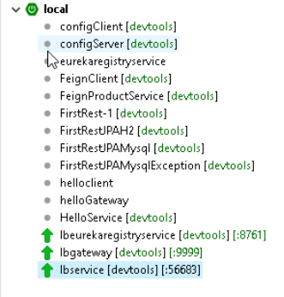Here u will see or run services or code only for once …to run multiple instances …right click on the project ..and press run as spring project or java….do this for 2 to 3 times to get 2 to 3 instances …instances in a easiest way is nothing but running entire project when it is already running

Like this 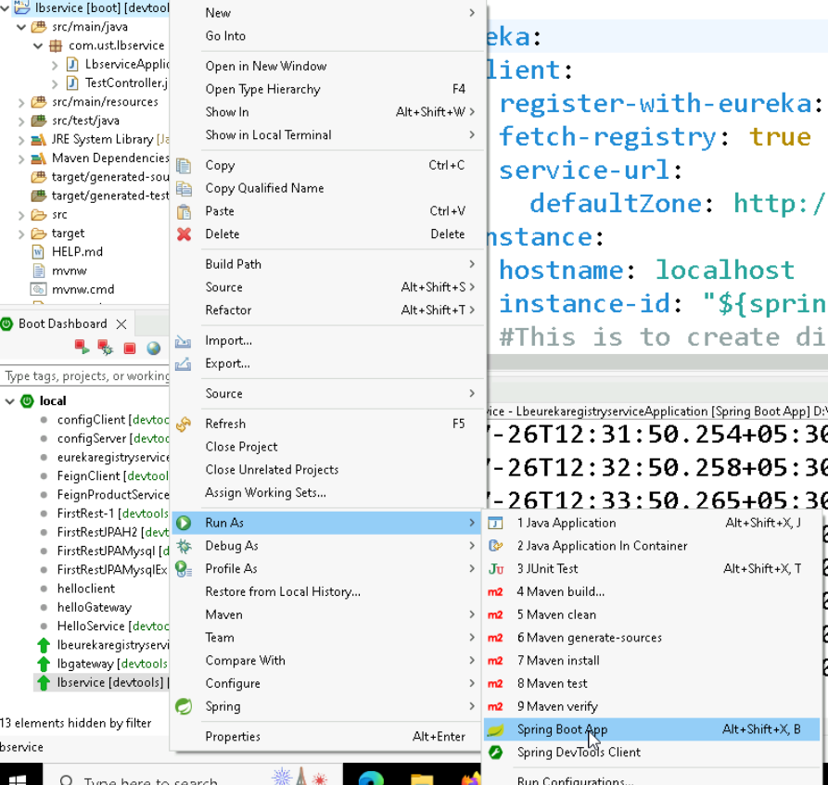

To check how many instances are running click here like shown below



Check the cursor ..u will find this there only

# SLEUTH

# (Loosely connected to logging(error logs)(not log in or log out)

It provides the

1. **application name**
2. **traceId**-id assigned to a single request
3. **spanId-**tracks a unit of work…Think of a request that consists of multiple steps. Each step could have its own spanId and be tracked individually.By default, any application flow will start the same Traceid and spanid

**export-**This property is a Boolean that indicates whether or not this log was exported to an aggregator

**[ application name, traceId, spanId, export](Sir definition)**

**Application name –** This is the name we set in the properties file, and can be used to aggregate logs from multiple instances of the same application.

**TraceId –** This is an id that’s assigned to a single request, job, or action. Something like each unique user initiated web request will have its own traceId.

**SpanId –** Tracks a unit of work. Think of a request that consists of multiple steps. Each step could have its own spanId and be tracked individually. By default, any application flow will start with the same TraceId and SpanId.

**Export –** This property is a boolean that indicates whether or not this log was exported to an aggregator like Zipkin. Zipkin is beyond the scope of this article, but plays an important role in analyzing logs created by Sleuth.

Sleuth was not working in our virtual machine ..so no code written …sir showed the sleuth program by running it ….saw that if spanid and traceid are same themn that means they are derived from same work …if oen is different that it has taken different work flow inside the same process .

Also these are not outputs there fore see in console..[<hexadecimal1>,<hexadecimal2>] u will find like this

Also sleuth doesnot work on spring version 3.x therefore we need to downgrad it to 2.7.x

**ZIPKIN:**

[**OpenZipkin · A distributed tracing system**](https://zipkin.io/)

**MicroMeter**

**-----------------------------End of microservices-------------------------**

**SECURITY:**

Security is implemented through **filters** or interceptors(Learn filters ..filters architecture perfectly without this it is hell)

[14. The Security Filter Chain (spring.io)](https://docs.spring.io/spring-security/site/docs/5.0.x/reference/html/security-filter-chain.html)

Security about AUTHENTICATION and AUTHORISATION (Learn about them)

CCC(Cross cutting concern)

1. How it works in java
2. How it works in spring

We don’t need to write any single line of code ..justimport the security package or dependency and it will add a security layer

Spring security is nothing but java configuration…since we cannot write logic in application.properties we need to mention in a configuration file

# DAY-10(27-07-24)

Yesterday tries the InMemoryAuthentication…now trying jdbcAuthentication on own

Filters needed to be learned..because we need to create atleast one user defined filter

New word (find):- AndMatchers

1. [JSON Web Token Introduction - jwt.io](https://jwt.io/introduction)
2. [Modular conversion, encoding and encryption online - cryptii](https://cryptii.com/)

How to execute:-

//After the code gets executed .. go to postmann...type localhost:8899 and click on post..then go to body..select raw and json and type{"username":"foo","password":"foo"}..foo because we have given that in the code //U will get the jwt token...copy that token

// then go to authorization in postmann..select the bearer token..paste the token without any double quotes etc..and then paste it over the side ..

//then click the localhost:8899/greet or user or admin...without token it wont work

# JENKINS:-

Jenkins is a popular and job providing tool….it helps in creating or performing ci/cd (continuous integration and continuous delivery)

It helps in automating the software development processes like building(the jars..once maven code gets into the github it will automatically gets doneto jar file by jenkins), testing etc etc

Jenkins will give feedback immediately…for everything it sends the mails

First it was called Hudson..written using java and servlets …latest docker is also integrated into it

It permanent port number is 8080.

IN Jenkins we create jobs..every thing is a job in the Jenkins.Jenkin is a plugin based system.

*.* …can start with any name and file can be of any type.. basically selecting all files

Build or maven or jenkin are interchangebaley used

# Day-11(29-07-24)

1. Complete Jenkins -pipeline (two types:- script based and ui based )
2. Circuit breaker -resilience 4j
3. Docker(Kubernetes-Messaging with rabbit MQ and kafka)-Loadbalancer + circuit breaker-AWS(Red:- might be next day or next week )
4. Migrate the store project to spring boot – microservices

# Jenkins Pipeline

What is a pipeline …a process or flow..the collection of stages ..When ever we say pipeline or build or deploy …that means the project undergoes all the stages ..same as life cycle of maven or given below

**Build**(not making jars..but pushing u r source code to repo) ->**Run quality gates** (Checking if the code ic clean or according to standards )-> **testing** & **generating all types of reports**-> **packaging** -> **deployment/Install**  -> **release**

**CI=Continuous integration = From run quality gates to packaging**

**CD=Continuous delivery= The other stages**

Two types of pipelines :

1. Script based (For this we use Groovy)
2. Ui Based

**Groovy:**

* In groovy, it is not necessary to put a semicolon at the end of the statement like in java.

**Example:**

  package com.app

  class Demo {

  static void main(args) {

print ("Welcome to Javatpoint tutorial on Groovy... ")

}  }

**Output:**

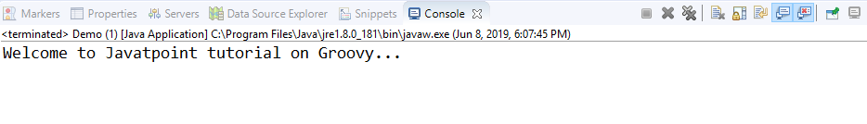

* **In groovy, we can print a line without using round brackets**

**Example:**

package com.app

class Demo {

static void main(args) {

print "Welcome to Javatpoint tutorial on Groovy... "

}  }

**Output:**

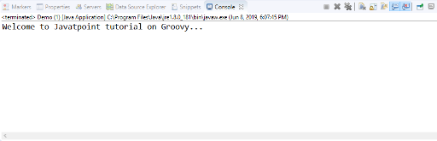

* **In groovy, double quotes as well as single quotes can be used in a string.**

**Example:**

package com.app

class Demo {

static void main(args) {

print 'Welcome to Javatpoint tutorial on Groovy...'

}  }

**Output:**

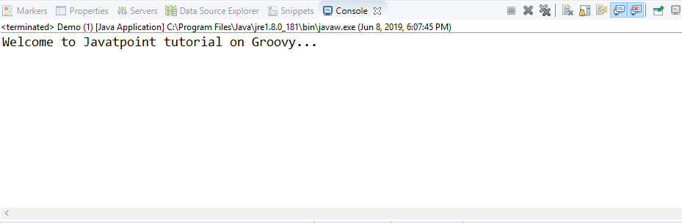

* **We can have a single line comment as well as a multi-line comment just like in java.**

**Example:**

package com.app

class Demo {

// this is a single line comment

/*

*

* this is a

* multi-line comment

*/

static void main(args) {

print "Welcome to Javatpoint tutorial on Groovy... "

}  }

**Output:**

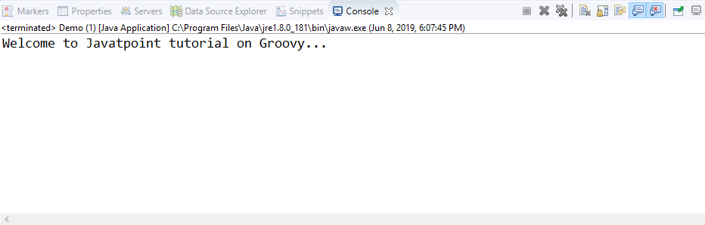

* **In Groovy, it is not necessary to have a class or the main function.**

**Example:**

package com.app

print "Welcome to Javatpoint tutorial on Groovy... "

**Output:**

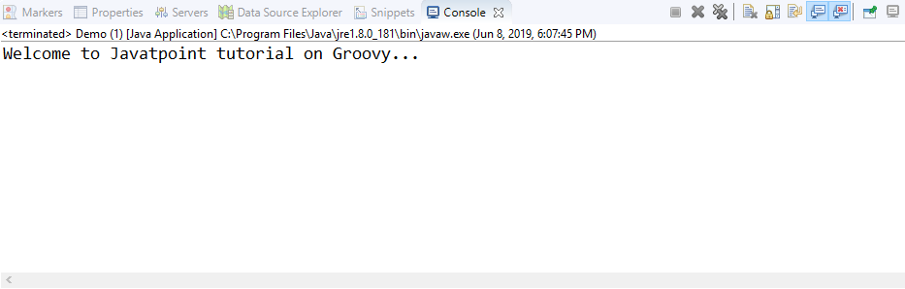

**Till** now we have created individual jobs in Jenkins …now we will create some standard declarative jobs.

# Resilience4j:-

1. [CircuitBreaker (readme.io)](https://resilience4j.readme.io/docs/circuitbreaker) (Best link…)(Easy and depth explanation)

**Client means we need to think or remember the rest template or bean or feign**

Sometimes the service or server might be down or not working etc ….

What does resilience does is that without sending the request to the service via client or gate way and returning back since the service is off or not accepting or not running (it is like a round way trip) …it will send a proxy request.

It will halt the api call …send a proxy request and also pings with the original request ..if proxy works…then sends the original request…else done

We need to and AOP dependency …remove discovery client dependency and eureka also…also paste this in the application.yml of client(Vvvvimp code …)

|  |  |
| --- | --- |
|  | resilience4j: |
|  | circuitbreaker: |
|  | instances: |
|  | clientService: |
|  | registerHealthIndicator: true |
|  | eventConsumerBufferSize: 10 |
|  | automaticTransitionFromOpenToHalfOpenEnabled: true |
|  | failureRateThreshold: 50 |
|  | minimumNumberOfCalls: 5 |
|  | permittedNumberOfCallsInHalfOpenState: 3 |
|  | slidingWindowSize: 10 |
|  | waitDurationInOpenState: 5s |
|  | slidingWindowType: COUNT_BASED |

@GetMapping

@CircuitBreaker(name=***CLIENT_SERVICE***,fallbackMethod="callOnFail_Mine")

**public** String callServer() {

String url="http://localhost:8071/rest/service";

String output=template.getForObject(url,String.**class**);

**return** output;

}//Lets call this as working method

**public** String callOnFail_Mine(Exception e) {

**return** "message from callonfail method created by me.....";

}//lets call this as fallback method

//IMportant Point: Both working and fallback method should have same return type..else wont work..if one a String or response entity other shoulf also have response entity

Learn what is buffered call,open close half open states , and when willit move from open to half open or vice versa and half open to close and close to open …and what is failure rate …research by trail and testing like the below manner …first run the service class (helloservice-resilient4j)(make sure the client also is running ..helloservice-resilient4jclient)

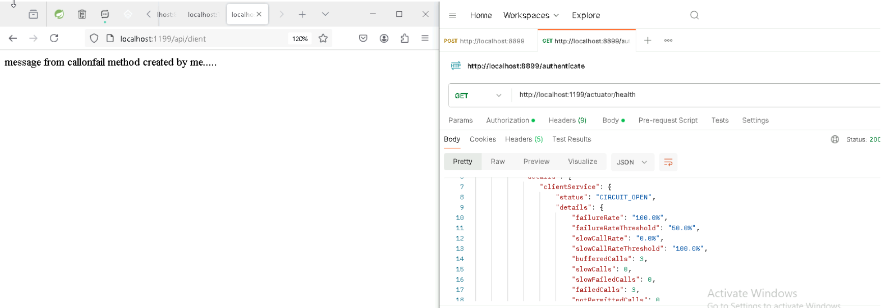

Then stop the service and do the same(it will go the callOnFail method)(Note the changes and numbers)

Read the circuit breaker link given above(Read again and again …very important)( [CircuitBreaker (readme.io)](https://resilience4j.readme.io/docs/circuitbreaker))

# DOCKER :-

1. [Docker Hub Container Image Library | App Containerization](https://hub.docker.com/)

Our **jars** files will become into an **image** …after running the image it will become the **container**..why image ..because all our files related to it or dependencies needed to be with them only.

Chef and puppet and anisble …for devops people to do automation

Virtualization vs containerization….first in personal laptop do the virtualization…using vmware..

When the load comes ..we can create the instances of the docker images very fastly and quickly .

Docker hub is for sharing the docker images ..like github  
**Docker Steps:-**

1. Create a new folder and switch(go to) that folder
2. Create a docker file( without any extension or it wont have a extension any how) (In that folder there should be only one docker file)
3. Define the libs / bins(libraries and binaries)
4. Build an image with docker file
5. Run the image file to instantiate the container – runtime instance of an image which based on docker file specification

To remove the extensions…open notepad …click on save as and type “file_name” …include the double quotes …after this it will create a file without any file extension

Also make sure to name the file as **“dockerfile”** …with quotes and small case letter with no spaces

* For Compiling use **RUN javac Hello.java** and to run **CMD [“java”,”Hello”](Else wont work..also we run the dot class file there fore we can write java Hello or java Hello.class**

Steps: (Commands to run)

**Step -1** (First Open the docker desktop app else wont run or work )

**Step -2 (**Open the working directory cmd )

* **docker build .** (along with the dot)
* **docker images**
* **docker run <image_hash_code>**
* since using hash is difficult ..we will rename
* **docker build -t <any name only in lower case>:v1 .** (dot is important) (include the dot ..which indicates self folder)(-t means tagging..i.e ur tagging a name to it..-t=tagging everywhere in docker) or docker built -t <anyname>:<anyname> . no need of v1 only(right side of : is just a tag ..left side is the name..when accessing use both like same way u have given)
* **docker run <name in lower case>:v1/v2/…./vn**
* -y …that means if there is an yes or no question …which will take y…..In ubuntu apt means like npm or pip…and also if ubuntu:20.4 not working type this ubuntu
* **docker ps -a** (To get all the running dockers)

# Day-12(30-07-24)

# DOCKER:-

**For docker commands go to hostinger tutorials website**

**vvvImp …web server are many like apache nginx etc ..do the certifications in these (better only one that is apache )** [**Welcome! - The Apache HTTP Server Project**](https://httpd.apache.org/)

In one command u will see… 9000:80 ..by default the image will run on 8080(but we give 80 only) but it is occupied by Jenkins we are saying map it to port 9000

FOREGROUND…blocks the cmd because of which we cant enter any more commands except ctrl + c and followed by word “exit” in next command

BACKGROUND….will not block the cmd and run the process at background

**-d is detached ..it will allow to use the cmd after we run the command else we cant use the cmd**

**-p …to set up port**

**docker run -d -p 9000:80 <docker image id>( u will get container id after u execute this command with image id or name …remember first image then it will convert to container ) ….then type localhost:9000 u will see apache website (actually depends on code written in dockerfile**)

**Now we have build the docker image …now if we want to edit ….then we can go inside the server and change it …**

**Steps :**

1. First build with name
2. Next run and check if the code is working or not
3. Now comes the changing part…
4. Type **..docker exec -it <containerid> bash**
5. **IMP:- Not image id the container id ..which u wil get immediately after second step**
6. -it ..means interactive ..and bash means we can edit
7. If there is no vim ..then install it ..using **apt install vim -y** ..then it will ask questions
8. Then go to the folder in which u have index.html…see the code written in dockerfile
9. Then press **vim index.html** or file name …
10. Press i(small I ..that means we can insert or that means we can change )
11. Press double esc(if u are in virtual machine) followed by :wq
12. Press exit 13)And refresh the webpage to see ur html output

We are using docker cli to interact with the **docker_host**….it has the **docker daemon**

* Docker daemon keeps entire environment alive ..a backend process

# Kubernetes:-

Open source container orchestration tool…developed by google

Helps manage containerized applications….we can put or deploy these containers anywhere examples like…aws gcp private or personal cloud etc

High availability or no downtime

**Architecture**:

* control plane or master
* Worker nodes / nodes…basically phy or virtual machine
* API server (Entrypoint to k8s cluster)
* Controller Manager(keeps the track of what’s happening in the cluster )
* Scheduler(Ensures pod placement)
* Etcd ( kubernetes backing store)

*Install minikubes from the website …*

**Commands**:- (In line wise)

1. minikube start –driver=docker
2. kubectl apply -f <deploymentfilename>.yaml
3. kubectl get deployment
4. kubectl get pods
5. kubectl apply -f <serverfilename>.yaml
6. kubectl get service
7. kubectl get service -o wide

kubectl port-forward service/<service_name>(check output of 5th command and use it) 7080:80 dockerimagename:tag

For future: kubectl scale deployment nginx-deployment –replicas=<replica_count> (If workload is increasing ….then we increase the replicas)

After this use curl or go to browser…and type localhost:7080( U will see nginix server message)

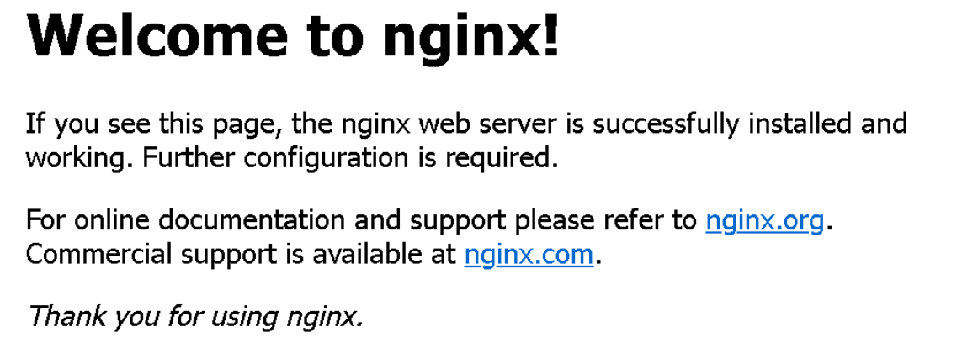

TASK:- Replace the above welcome to nginix to …our own …to get how can we access or change the code files

Or How do u go into the container and add the index.html file ?

SOLUTION(Method -1)

1. kubectl exec -it service/ngnix-svc - - bash
2. ls
3. cd usr
4. ls
5. cd nginx
6. ls
7. cat > index.html
8. Add then code directly …inside the terminal only
9. For the step 7 if u execute that ….u r file contents wont be saved
10. Therefore install the vim on the root ..i.e outside of the container …i.e root folder

What ever you do in kuberneter dockerfile..the commands …we need to us those in the command line …with different command like we used COPY but here we wont(IGuess)

**SOLUTION-2( Using the already creted docker)**

**By default it wil take images from docker hub only not from local machines**

---------------------------------------

**docker tag <old image name>:<old image name tag> <username>/<new name with tag>**

**docker push <username>/<new name with tag>**

First login **…docker login**

Give user name ..and give personal access token in place of password(since u did with signup with github i.e no password)

**/* Give the token as read write delete permission …else wont work */**

for example:

docker tag hello-app:latest anilboppuri/dockerhub:hello-app

docker push anilboppuri/dockerhub:hello-app

**ERROR + SOLUTION:- (Insufficent scopes )(U will get this while pushing the docker image into the docker hub)**

**When u get the insufficient scopes error in the docker…make sure to change the permissions of the access token to read write and delete …**

Step-1 :- docker login

Step02 :- Give user name and access token

**Step03:-** Change the access token permission from the website

**Step04:-** use **docker tag <dockerimage name> <dockerhubsuername>/<dockerhubimagename>**

**Step05:-**Use **docker push <dockerhubsuername>/<dockerhubimagename>**

**Step06:-** Go to docker hub website and check if the docker image u pushed is present or not

**Step07:**- If not working try creating a repository in docker hub and take that name and keep in step04 command

**Kubectl commands :- (Given by sir)**

minikube start --driver=docker

kubectl apply -f nginx-dep.yaml or kubectl create -f nginx.yaml

kubectl get deploymentsn / pods

kubectl apply -f nginx-serv.yaml

kubectl get svc -o wide

# not working kubectl expose deployment nginx-svc --type=NodePort --port=8080

kubectl port-forward service/nginx-svc 7080:80

go to browser or curl localhost:7080

kubectl exec -it service/nginx-svc -- bash to enter into the running container on POD to make changes to your index.html

kubectl scale deployment nginx-deployment --replicas=<replica_count>

kubectl describe nodes <node-name>

kubectl describe pods <pod-name>

kubectl cluster-info

----------------------------------------------------------------------------------------------------------------------------------------

**My TRIES for above question (didn’t work)**

D:\kubernetes-ust>**kubectl apply -f deployment.yaml**

The Deployment "74c181146a08fc52ce3228bb74cef7e4eda984924abfaf13f513f73e174974de" is invalid:

* spec.selector.matchLabels: Invalid value: "74c181146a08fc52ce3228bb74cef7e4eda984924abfaf13f513f73e174974de": must be no more than 63 characters

* spec.selector: Invalid value: v1.LabelSelector{MatchLabels:map[string]string{"app":"74c181146a08fc52ce3228bb74cef7e4eda984924abfaf13f513f73e174974de"}, MatchExpressions:[]v1.LabelSelectorRequirement(nil)}: invalid label selector

D:\kubernetes-ust>**kubectl apply -f deployment.yaml**

The Deployment "74c18114" is invalid: spec.template.metadata.labels: Invalid value: map[string]string{"app":"my-html-app"}: `selector` does not match template `labels`

D:\kubernetes-ust>**kubectl apply -f deployment.yaml**

deployment.apps/74c18114 created

D:\kubernetes-ust>**kubectl apply -f service.yaml**

The Service "74c18114" is invalid: metadata.name: Invalid value: "74c18114": a DNS-1035 label must consist of lower case alphanumeric characters or '-', start with an alphabetic character, and end with an alphanumeric character (e.g. 'my-name',  or 'abc-123', regex used for validation is '[a-z]([-a-z0-9]*[a-z0-9])?')

D:\kubernetes-ust>**kubectl apply -f service.yaml**

service/my-html-service created

D:\kubernetes-ust>**minikube service my-html-service –url**

**(Not workin) (Try using kubectl instead of minikube)(kubectl for this command wont work ..try using kubectl port-forward service/<service_name> 7081:8080**

**Kubectl get pods (To see if our images are in running states or not ..it should be in running state only**

**Kubectl port-forward service/<service name given in the service.yaml> 9091:80**

**---------------------------------------------------------------------------------------------------------------------------------------------**

**In deployment.yaml …give the name of docker image pushed in the docker hub ….**

**Open docker hub website …click on 9 dots….click repositories ….u will see the docker image name…use that name only ……**

# DAY-13(31-07-24)

**Procedure for deploying the image into docker hub and running it using kubectl :-**

**Execute the commands and steps in order:**

1. docker images(Before that docker login..and give personal access token ..also change the permission to read write and delete of personal access token..else u will get insufficient tokens error)
2. check if the docker image u want is there or not
3. docker tag <dockerimagename>:<tagname> <usernamedockerhub>/<newreponame>
4. This new repo name can directly be kept or create a new repository in docker hub by clicking the 9 dots and clicking the repository..u will see the repository and can create a new one
5. Now type the command **minikube start --driver=docker**
6. Then type notepad in cmd ..create a file(deployment.yaml) or any file name
7. Then again type notepad in cmd..create a file(service.yaml) or any file name
8. Now type **kubectl apply -f deployment_filename.yaml**
9. Now type **kubectl apply -f service_filename.yaml**
10. **For steps 6,7 try keeping the names in lower case only …and for image name give ur username/imagename:tagname(if any tag name is not there then remove it)**

# Java Messaging Services: -

[Java Message Service (JMS) (oracle.com)](https://www.oracle.com/java/technologies/java-message-service.html)

[Getting Started with Java Message Service (JMS) (oracle.com)](https://www.oracle.com/technical-resources/articles/java/intro-java-message-service.html)

# RabbitMQ:-

[RabbitMQ: One broker to queue them all | RabbitMQ](https://www.rabbitmq.com/)

# Kafka:-

[Apache Kafka](https://kafka.apache.org/documentation/)

# AWS:-

Topics covered: IAM,EC2,RDS,S3(simple storage service)(non relational data),users-groups-policies

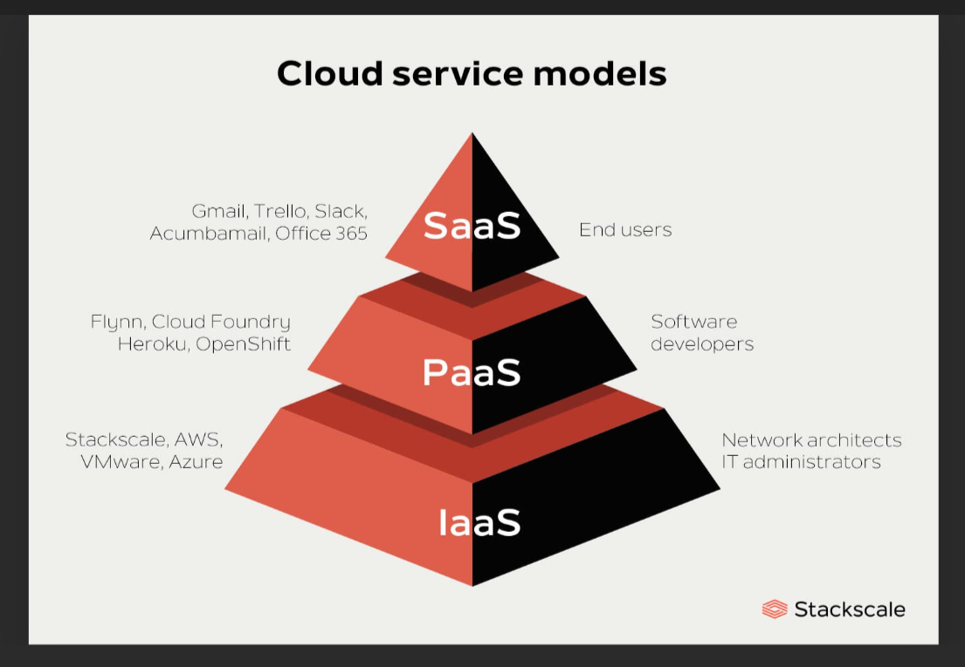

# DAY-14(01-08-2024)

Any cloud infrastructure …there are regions…and each region has few availability zones for fault tolerance …(duplication of data)(Backups) …Each availability zone have two or more data centers(again same,for backups…they will have their own backups with in a zone and also within a region )

We can create groups in aws..and provide the policies or permissions on who will do what or what cant do.

Groups is a collection of users with same permissions or privileges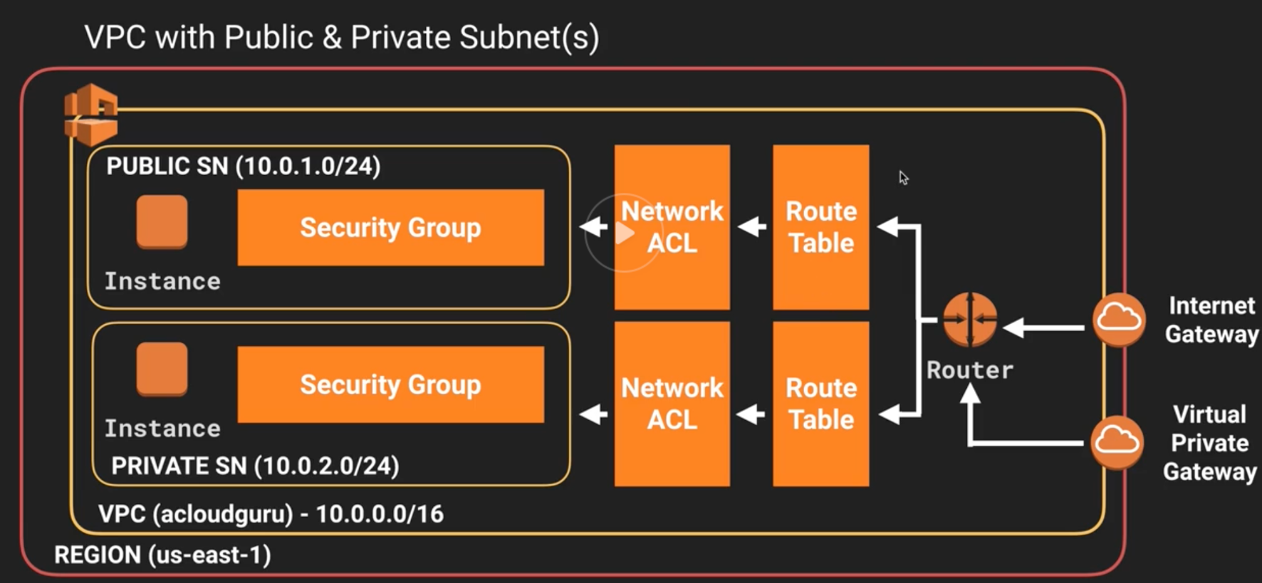

S3 is not for relational data.. only for non-relational data ….it is used to store images videos etc

**STEPS:- (S3)**

Create a bucket

Upload the files

Then go back to the buckets section

Open the bucket ..u will see the files (which are called as objects)

Go to permissions tab

U will see bucket policy at the bottom

Click edit the bucket

Paste the code …here the * means ..all …that means all files , all principles ..all actions etc etc

Now go to bucket ….open it ..open the file ….u will see the url .click it u will see the file contents

Or Else u can do using GUI ..

Delete the above bucket policy code

Go to bucket select it

Select an object

U will see (if acl is diabaled) ..” bucket owner enforce” in the top banner

Enable the ACL

After that ..selct the bucket and also select an object

U will see a drop down(Objects actions) at right side…now u will see “Make it public using ACL“..click it

Now clik the url present over there…that it

How to CONNECT the RDS in the EC2 instance

(Not direct inside the rds website of aws.. but using cmd inside ec2 isntance…its like using ec2 like our computer):

Step 1:- use ubuntu image (just select the ubuntu image in the ec2 isntance)

Step 2:- Then type **sudo apt-get install mysql-client**

Step 3:- Then type **mysql -u <username> -p -h <endpoint>**

Step 4:- Then type the password given to the rds database ..generally the username will be “admin”

..but better check again from the rds

Step-5(Do before step 2):- Go to ec2 ->instances->click on one of the instanceId->scroll down and u will find the image-1->click the thing where the cursor was placed in the image->Now refer the image 2 and click where the cursor is placed in the image -> After hat do the image-3 first line(mysql/auroa)->press this and **SAVE …**

**Image-1**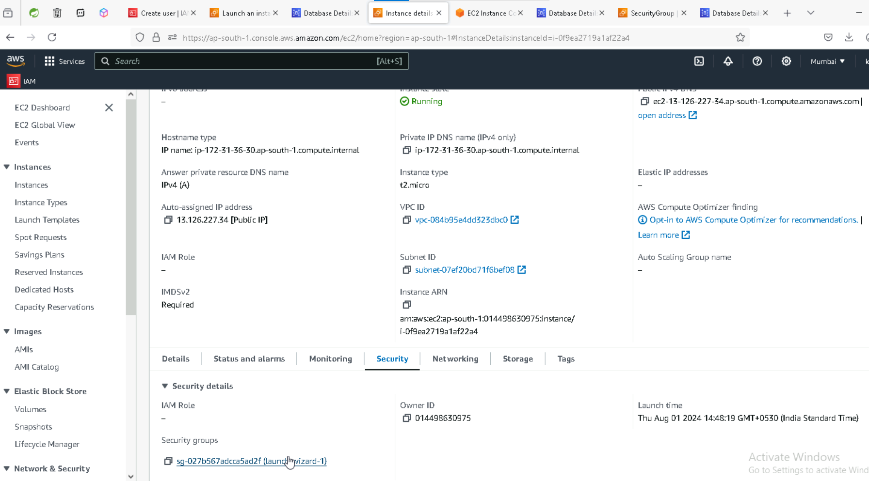



**IMAGE_2:-**

**IMAGE-3:-**

If u connect ..u will see this (All these u will see from the connections and security tab after selecting the database)

# ELASTIC BEAN STALK:-

The role name …**aws-beanstalkservice-ec2-role**…..we can keep any name …but be very careful…the meaning of this is …this role is allowing elasticbeanstalk to access the ec2 instance

# DAY-15(02/08/2024)

What are learned yesterday:-

1. AWS-EC2 what are compute services ,Creating instance, security groups, key pair, inbound ports, SSH, putty on windows, VPC, subnets, connecting through RDS, start stop terminate EC2,region,availability zone, data center (Find the meaning of serverless etc)
2. USERS, Groups, Roles, policies->IAM(little bit)
3. S3 bucket, how to create bucket and upload files, giving public access the files, ACL script, policies, difference between s3 and relational database
4. RDS – how to launch rds mysql server, connecting to local machnine using mysql workbench
5. Integrating-EC2 with RDS service
6. ElasticBeanStalk(intro)(Created two roles)

Today:-

1. Elastic bean stalk-deploying spring boot application
2. AWS code commits(Just removed after July 25 2024)
3. AWS ECR
4. AWS Pipeline
5. Complete AWS pipeline

# Elastic bean stalk-deploying spring boot application

**Steps:**

1. First create a spring boot application with simple service class..with one end point or url(for demo sake)(No idea if docker file should be there or not)
2. Make sure the **application.properties** the server.port=5000….make sure to keep the port number as 5000…
3. Go to aws ..then go to elastic bean stalk(Select the coretto 17 if ur java version is 17 in u r project)

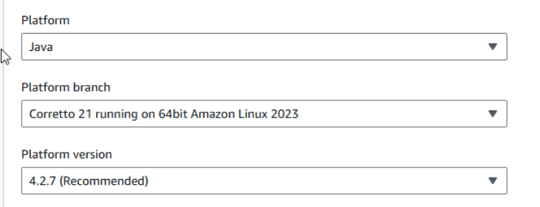

1. Then select the **Elastic bean ..**not ec2(No idea if this step if for our task or for another task)
2. After the site gets deployed click on url…example:- Kausthub.elaticbeanstalk.com

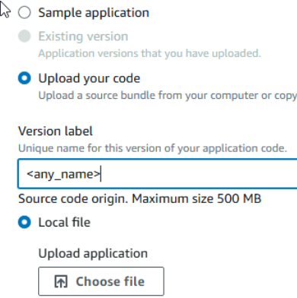

1. Select the jar file ..the original one…

1. In the next step keep these two services only in the same order..if not created then create them and keep the necessary policies in them

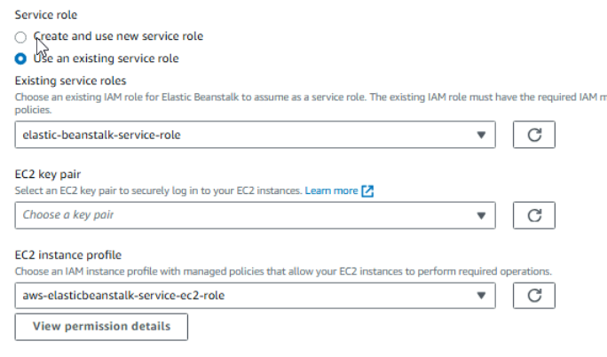

1. Then click **skip to review** button…..then click on **submit**
2. U will get a blue ribbon like this (which should turn green ..so wait little long)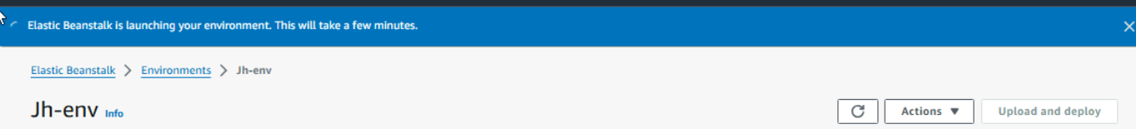
3. And down u can see the logs

1. Then write u r url end point after .com..exmaple Kausthub.elasticbeanstalk.com/rest/service/evenodd/5

Type the url like this (just keep the end point after the .com)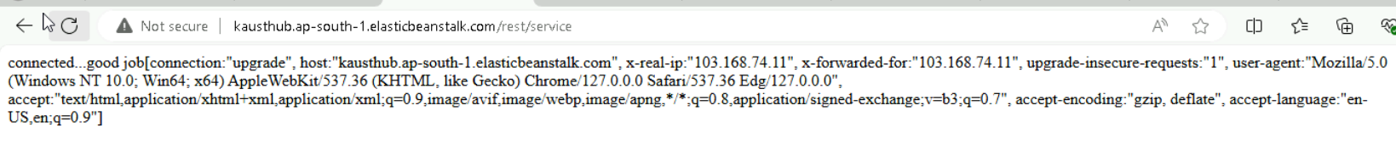

Else u will get like this

**DONOT FORGET to delete all the BEAN STALK, INSTANCES ,RDS ,ENVIRONMENTS(or else will be charged heavily)(In same order..by default beanstalk will use some instance ..so if u delete instance first ..bean stalk will again create an instance..therefore delete the bean stalk first followed by instances..compulsoryily do both bean stalk an instances)**

**TASK:-**Try deploying using inmemory(do direct) and rds(just give the rds details in the database thing in environment)

**HOW TO CONNECT THE AWS FROM LOCAL CMD AND SEND THE DOCKER IMAGES:- (Either local or u can do directly create docker images from the cmd of amazon aws ..located at the bottom left)(called as cloudshell)**

1. Create a repository in the aws…inside this repository only u will see the images u have inserted
2. Now open u r cmd and docker desktop(to insert the docker images)
3. Accessing AWS from local CLI

1. create a user with full admin privilieges

create user -> choose **Attaches policies directly** -> attach **AdminstratorAccess**

2. once user is created -> select the user -> select security credentials tab -> choose access key > copy or dowload the access key and token

4) Open the cmd ..and type this command …u can refer this website

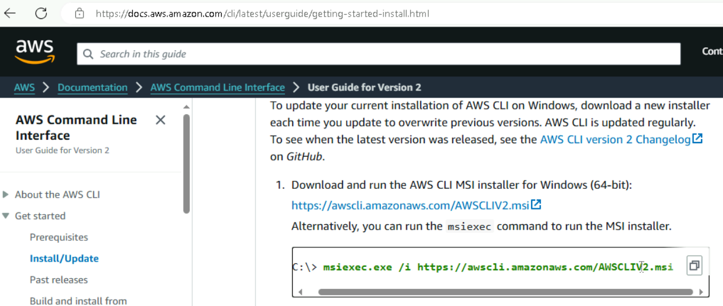

Now after that type the command: **aws configure** (U will see all these steps in the “push commands “ in the repository

AWS Access Key ID [None]: enter access token

AWS Secret Access Key [None]: enter access key

Default region name [None]t : enter us-east-1

Default output format [None]: enter json

5). copy this command from ECR repository and paste it

aws ecr get-login-password --region us-east-1 | docker login --username AWS --password-stdin 905418250063.dkr.ecr.us-east-1.amazonaws.com

6). create a docker image with the name abrepoust:latest this you will do it in a folder which has a Dockerfile

7). docker tag abrepoust:latest 905418250063.dkr.ecr.us-east-1.amazonaws.com/abrepoust:latest

8). docker push 905418250063.dkr.ecr.us-east-1.amazonaws.com/abrepoust:latest

# DAY-16(03/08/24)

**ECS(Elastic container Service)**(Will cost us heavly and fastly ..min: 30$)

Steps:-

1. Create ECR and push latest image

**NOTES(**GIVEN **BY SIR):-**

https://docs.aws.amazon.com/prescriptive-guidance/latest/patterns/deploy-a-ci-cd-pipeline-for-java-microservices-on-amazon-ecs.html

Steps to build ECS on AWS

----------------------------------------------

Boot on AWS-ECS

1. create Dockerfile

2. create ECR repo

3. create a buildspec.yml file in the sprinboot project root

pre_build

build jar, goto repo login create a commit hash extract first 7 chars and tag it to create a unique image name

build

post_build

Note: push all the changes made to springboot project to github

4.0 create a role for codebuild to access ECS

bootdocker-codebuild-eks-role

Two permissions:

AmazonEC2ContainerRegistryFullAccess

AmazonEC2ContainerRegistryPowerUser

4.1 Create a codebuild project

1. name

2. link to github

3. give a role-name choose the role created in step 4.0

4. create build project

5. Start build and verify ECR registry

5. Goto ECS

1. create Task definitions

2. launch type - Fargate

3. Container -1 give ECR container registry name and URI (dont give image uri)

4. container port 8080 app protocol http

5. create

6. create cluster

7.name

8. infrastructure Fargate

9. create

10. goto newly created cluster

11. click on create service

12. compute options choose LaunchType -

13. capacity provider : AWS Fargate

14. Platform version : LATEST

15. click Application Type : Service

16. Tasks definitions -

Family

Choose the task definition created in steps 1-5 Revision : LATEST

17. service name : bootdocker-service

18. Networking : create new security group

19. Allow all traffic coming from anywhere

20. Allow all TCP coming from anywhere

21. create

after created successfully

22. go to the cluster -> open cluster -> click on created service -> tasks -> open task -> you will find a public ip click on that public ip

23. edit codebuild project -> priamary source webhook events -> check the checkbox - Rebuild every time a code change is pused to repository click on update project

----------------

6. Build pipeline

1. name

2. new service role - accept the name given

3. next

4. source provider GitHub connect to GitHub

5. choose repo - bootdocker

6. branch master

7. GitHub webhooks

next

8. build provider - choose AWS Codebuild

9. choose codebuild project created in step 4.1

10. single build

11. next

12. Add Deploy stage - choose Amazon ECS container -watch the region carefully all services must be in same region

13. choose cluster name created in step 5.6

14. choose service name create in step 5.17

15. next

16. create pipeline

**To access the endpoints …make sure to add the port number at the end ..example:- 23.43.55.8080/rest/service …u will get only 23.43.55**

-------------------------------------------------

version: 0.2

phases:

pre_build:

commands:

- mvn clean install

- echo Logging in to Amazon ECR...

- aws --version

- REPOSITORY_URI=<paste ECR repo uri>

- aws ecr get-login-password --region ap-south-1 | docker login --username AWS --password-stdin $REPOSITORY_URI

- COMMIT_HASH=$(echo $CODEBUILD_RESOLVED_SOURCE_VERSION | cut -c 1-7)

- IMAGE_TAG=build-$(echo $CODEBUILD_BUILD_ID | awk -F":" '{print $2}')

build:

commands:

- echo Build started on `date`

- echo Building the Docker image...

- docker build -t $REPOSITORY_URI:latest .

- docker tag $REPOSITORY_URI:latest $REPOSITORY_URI:$IMAGE_TAG

post_build:

commands:

- echo Build completed on `date`

- echo Pushing the Docker images...

- docker push $REPOSITORY_URI:latest

- docker push $REPOSITORY_URI:$IMAGE_TAG

- echo Writing image definitions file...

- printf '[{"name":"bootdocker","imageUri":"%s"}]' $REPOSITORY_URI:$IMAGE_TAG > imagedefinitions.json

- echo Writing image definitions file...

# add your container name ie. ECR repository name which is also known as Note: keep ecr registry name and ecs

#container name same, if they are different then give ecs -task -> container name

- DOCKER_CONTAINER_NAME=bootdocker

- printf '[{"name":"%s","imageUri":"%s"}]' $DOCKER_CONTAINER_NAME $REPOSITORY_URI:$IMAGE_TAG > imagedefinitions.json

- echo $DOCKER_CONTAINER_NAME

- echo printing imagedefinitions.json

- cat imagedefinitions.json

artifacts:

files:

- imagedefinitions.json

- target/bootdocker.jar

# DAY-17(05/08/2024)

Java how to program – by paul Dietal and Dietal

50 Algorithms ..master them

Hackerrank – Badges

Certifications

Phd

**Today:-**

Serialization

RabbitMQ

Kafka

AWS(Lambda,SNS)

**RabiitMQ:-**

Broker…queue

Listener..when some changes happen and client wants to see

**MICROSERVICES have two things ..a service(which gives there services) ….and a client(which uses the servies…can be the human or a service which needs other service)**

**What is Loose Coupling:-**

**Loosely coupled** can be achieved using **abstraction**..abstraction can be achieved using **interfaces**

[Coupling in Java - GeeksforGeeks](https://www.geeksforgeeks.org/coupling-in-java/)(vvvvimp..mainly the codes)

Dependency of a class with another class

Task t1=new Task_1(); ,….Task is interface …Task_1 is the class implementing it(Just showing how to write the code)

**Messaging system helps in building loosely coupled applications….**

**What is serialization:**

Serialization is a **MARKER INTERFACE(**an interface which has no methods) ….it stores and sends data in bytes…marshalling & unmarshaling and serialization & deserialization both are same

PREPARE FOR TECHNICAL TOPIC PRESENTATION(from spring, spring boot etc)

# KAFKA:-

# Zookeeper is the cluster for kafka (For me neither the zookeeper nor the kafka was getting started)

[What Is ZooKeeper? | Using Kafka and ZooKeeper | OpenLogic by Perforce](https://www.openlogic.com/blog/using-kafka-zookeeper)

[Kafka vs. RabbitMQ: Features and Use Cases | OpenLogic by Perforce](https://www.openlogic.com/blog/kafka-vs-rabbitmq)

[Event Streaming and Apache Kafka in Telco Business (OSS/BSS) - DZone](https://dzone.com/articles/event-streaming-and-apache-kafka-in-telco-business)

How to configure:

1. Add the path of kafka bin in system environment variables
2. Then go to tha kafka folder
3. Search and open config folder
4. Inside it open the zookeeper file in notepad
5. And in that add the bin folder (\bin) location in the “datadir:________”
6. And one more is there to do inside the **server** file

Whatever we do we need to do two projects:-1) kafka Producer2) kafka consumer  
…These are pure **java projects** not spring etc…

* Make sure the java project has no **module-info** folder
* To make kafka work…right click on the project …do the below A screenshot of a computer

  Description automatically generated
* Select the kafka folder..inside it select the libs…select all and press ok .

NOTES Given by sir:- .\bin\windows\kafka-console-producer --broker-list localhost:9092 --topic source-topic --property "parse.key=true" --property "key.separator=:"

.\bin\windows\kafka-console-consumer --bootstrap-server localhost:9092 --topic UST-TRV --from-beginning

----------------------------------------------(The below is to be pasted in properties file)

log4j.rootLogger=INFO, stdout

log4j.appender.stdout=org.apache.log4j.ConsoleAppender

log4j.appender.stdout.Target=System.out

log4j.appender.stdout.layout=o.\bin\windows\kafka-console-producer --broker-list localhost:9092 --topic source-topic --property "parse.key=true" --property "key.separator=:"rg.apache.log4j.PatternLayout

log4j.appender.stdout.layout.ConversionPattern=%d{yy/MM/dd HH:mm:ss} %p %c{2}: %m%n

# LAMBDA(AWS LAMBDA)

# SNS(Simple notification service)

# (Push Notifications in AWS)(To understand this we need to understand the rabbitmq)

# DAY-18(06/08/2024)

[What Is Federated Authentication? How It Improves Security (g2.com)](https://learn.g2.com/federated-authentication)

[Understanding SAML | Okta Developer](https://developer.okta.com/docs/concepts/saml/)

[OAuth 2.0 and OpenID Connect overview | Okta Developer](https://developer.okta.com/docs/concepts/oauth-openid/)

Federated Authentication is nothing but similar to sign in with google

Federated Authentication can be implemented in three ways

1. SAML 2) OAuth 3) OpenId

More on Oauth …codes on building using google facebook github etc

|  |
| --- |
|  |
| **https://github.com/spring-projects/spring-security/blame/main/config/src/main/java/org/springframework/security/config/oauth2/client/CommonOAuth2Provider.java** |
|  |

(Link for google,github etc authentication)

# DAY-19(07/08/2024)

# W3C:-

No matter what u need to follow these standards …there will be a compliance team also..since the global clients wont accept the local standards(Fir any project use these standards)

HTML came from SGML..HTML is a markup language not a programming language…HTML is nether compiler nor interpreted…there is a concept called PARSING for html..(trees concepts are used in HTML DOM..)

when u try to request a page:-

1. DNS will be happen first(Domain name service)(web or host names to IP addresses)
2. TCP/TLS handshakes
3. Fetch webpage from server
4. Browser parses and renders html response
5. Browser handles post load user interactions with the page

* Html file names should be in lower case

When u create a xml file in sts or eclipse and right click on the file u will see validate option…means checking if correct or not

Wellfound vs validate

div.container>div*3>h3*3

Three divs inside a div of class container …each div has h3 tag

Resource:- (One stop) [HTML: HyperText Markup Language | MDN (mozilla.org)](https://developer.mozilla.org/en-US/docs/Web/HTML)

Span and div are big headache to replace that semantics are introduced

This is an example of semantics(learn more)

head>h4{UST TVD}>nav>ul>li*3{click $}+main>section*3>article*3>p>lorem10+aside*2{hello $}..click enter

“>”means that whatever is the right of this are child of left

“+” means left and right of plus both are in same level

        (head>h4{UST TVD}>nav>ul>li*3{click$})+(main>section*3>article*3>p>lorem10+aside*2{hello$})+(footer>p+ul>li*2>a:link*2{click$})

HTML provides only static pages and navigation using anchor tag (<a ></a>)example :- <a href></a>…..the interactivity is not supported ..the interactivity is supported by javascript

Website vs webapp…website is like newspaper …same rendering for everyone …webapp is like newspaper but online example Eenadu.net…u can news of hyderbad news of rangareddy etc

Give this command so that the value and the display purpose drop down …both are added directly ..no need of manual typing

Java script provides interactive…and dynamic is provided using server side

**Difference between value , Id, Name in html:- (know more about it)**

Id is used to identify uniquely in a page (Id is never sent to server side)

Name is used to identify what to be sent to server side

Name and value go as a pair (or map)..name is like a key ..if u want to access the value u need key I,e here name

# DAY-20(08/08/2024)

**Span tag-**

The **<span>** [HTML](https://developer.mozilla.org/en-US/docs/Web/HTML) element is a generic inline container for phrasing content, which does not inherently represent anything. It can be used to group elements for styling purposes (using the [class](https://developer.mozilla.org/en-US/docs/Web/HTML/Global_attributes#class) or [id](https://developer.mozilla.org/en-US/docs/Web/HTML/Global_attributes#id) attributes), or because they share attribute values, such as [lang](https://developer.mozilla.org/en-US/docs/Web/HTML/Global_attributes#lang). It should be used only when no other semantic element is appropriate. <span> is very much like a [<div>](https://developer.mozilla.org/en-US/docs/Web/HTML/Element/div) element, but [<div>](https://developer.mozilla.org/en-US/docs/Web/HTML/Element/div) is a [block-level element](https://developer.mozilla.org/en-US/docs/Glossary/Block-level_content) whereas a <span> is an [inline-level element](https://developer.mozilla.org/en-US/docs/Glossary/Inline-level_content).

So basically it is used for styling using css or making some animations using java script ..other than that ..it has no effect or no output of its own

# BOOTSTARP:-

What ever bootstrap does is class based…that it uses and takes classes

Added on top of html …to avoid the styling using css

Best resource:- [Bootstrap · The most popular HTML, CSS, and JS library in the world. (getbootstrap.com)](https://getbootstrap.com/)

Other resources:- (Inside bootstrap)

[Background · Bootstrap v5.3 (getbootstrap.com)](https://getbootstrap.com/docs/5.3/utilities/background/)

[Tables · Bootstrap v5.3 (getbootstrap.com)](https://getbootstrap.com/docs/5.3/content/tables/#overview)

[Buttons · Bootstrap v5.3 (getbootstrap.com)](https://getbootstrap.com/docs/5.3/components/buttons/)

[Select · Bootstrap v5.3 (getbootstrap.com)](https://getbootstrap.com/docs/5.3/forms/select/)

[Range · Bootstrap v5.3 (getbootstrap.com)](https://getbootstrap.com/docs/5.3/forms/range/)

[Checks and radios · Bootstrap v5.3 (getbootstrap.com)](https://getbootstrap.com/docs/5.3/forms/checks-radios/)

[Background · Bootstrap v5.3 (getbootstrap.com)](https://getbootstrap.com/docs/5.3/utilities/background/)(U can try on the heading also ..just keep in h1 tag)

[Cards · Bootstrap v5.3 (getbootstrap.com)](https://getbootstrap.com/docs/5.3/components/card/#body)

**HOW TO USE BOOTSTRAP:-**

In two ways we can use the bootstrap …using cdn(urls) or using npm

…If using cdn it is very important to keep these things at head …

**<link** href="https://cdn.jsdelivr.net/npm/bootstrap@5.3.3/dist/css/bootstrap.min.css" rel="stylesheet" integrity="sha384-QWTKZyjpPEjISv5WaRU9OFeRpok6YctnYmDr5pNlyT2bRjXh0JMhjY6hW+ALEwIH" crossorigin="anonymous">

**<script** src="https://cdn.jsdelivr.net/npm/bootstrap@5.3.3/dist/js/bootstrap.bundle.min.js" integrity="sha384-YvpcrYf0tY3lHB60NNkmXc5s9fDVZLESaAA55NDzOxhy9GkcIdslK1eN7N6jIeHz" crossorigin="anonymous"></script>

**<link** rel="stylesheet" href="<filename>.css" >

Keep ur bootstrap css and bootstarp html file same names..to avoid confusion

u need to paste this in body to get the bg colur ..or anything same

<body class="p-3 mb-2 bg-info-subtle text-info-emphasis”>

U can give separate colours for each row or each column or each cell.

# FONTS:

Best Resource:-

[Browse Fonts - Google Fonts](https://fonts.google.com/)

There are two codes …after once we select a font a…select a weight ..click on get font

One should go to head and other should go to css

# Search engine optimization:

Meta tags deals with showing ur results on page…..just type “meta” and u will see suggestions..paste all those …

(ig) responsive ness is about shrinking and getting the information in the vertical position…not like loosing information once the screen(here different phones) shrink

# DAY-21(09/08/24)

# CSS(Cascading style sheet)

CSS tries to propagate downwards..(cascading means propagating downwards)

i.e body->div->h1 ..what ever changes u make at body level…it will change the div and h1 level ..similarly whatever changes u make at div level it will effect all the h1 …not the h1 to div or div to body

Why css..it is best example for externalisation…just imagine going to each and every h1 and keeping a colour tag ..its hectic..therefore we use .h1 in css and access all h1’s

Styling can be done at 3 levels:

1. Element level(also called inline)

Example:- <h1 style=”colour:#4545;font:font-familiy; font-size=24px”>

Same problem as disused above

1. Page Level – effects elements in a single page
2. External style sheet-easy to change globally to all html files, maintaining easy..

What ever u do at (3) will get overrided by (2) …not (2) gets overrided by (3) …the nearest ones overrides the top ones

Everything about css is about **selectors**…in some cases using element or tags for changing is not best since it will have a cascading effect…if u want to change only one element using id is the best…

Types of selectors:- [selectors are accessed by

.(<selector>){

} ]

1. Universal selector(*{})
2. Element/type (body,h1,ol,li,etc)
3. Group (div,span)
4. Grouping selector (div p or div h2)
5. ID ( #<idname>)
6. Class ( .<classname>)(dot..class…lets keep dc)
7. Attribute
8. Pseudo
9. Pseudo nth child
10. Pseudo element
11. Descendant (p h3)
12. Child (>)(ex:- div>p>h1)
13. Adjacent (+)
14. General sibiling
15. Complex selectors -compound

[CSS Selectors - GeeksforGeeks](https://www.geeksforgeeks.org/css-selectors/)

<https://dev.to/underscorecode/css-selectors-the-full-reference-guide-3cbf>

We can use both bootstarp and css …just make sure that u keep the cdn of bootstrap and place it on top after that keep ur css file …like below

<link href="https://cdn.jsdelivr.net/npm/bootstrap@5.3.3/dist/css/bootstrap.min.css" rel="stylesheet" integrity="sha384-QWTKZyjpPEjISv5WaRU9OFeRpok6YctnYmDr5pNlyT2bRjXh0JMhjY6hW+ALEwIH" crossorigin="anonymous">

    <link rel="stylesheet" href="first-css.css">

Also don’t give any class name as “container” (when using both bootstrap and css _…because container is present in the bootstrap

There are 3 types of styling in html ..**inline styling ,external styling and internal styling**

Inline styling is using inside tags like attributes …<div style:”background-color:red;font-size:90px”>

External styling is .css file

Internal styling is using the tag ..like <style >background-color:red;</style>

# DAY-22(10/08/24):

Learn perfectly:

1. Grid layout
2. Flex layout
3. Align content, justify content, align items, align content
4. SEMANTIC TAGS(vvvvimp)
5. Make websites responsive(media queries)

Try using emmiters instead of typing everything manually …practise it

        div[class="conatiner$"]*9>{$}

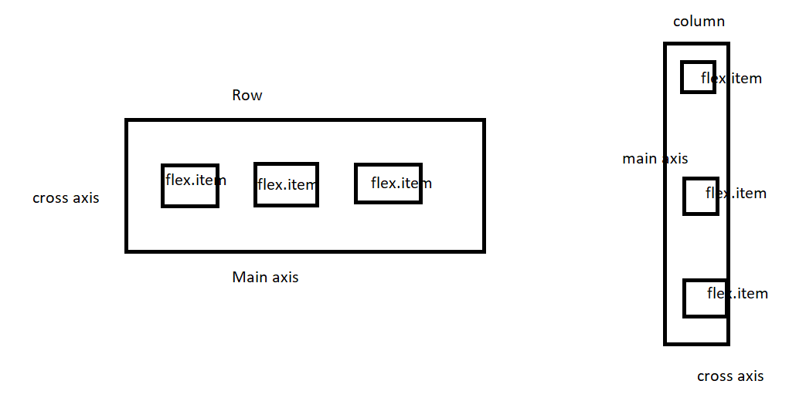

**CSS Grid ,flex layouts** are very very important for sake of building websites….

We use **display:grid;**

**display-template-rows**:1fx 1fx …(how many rows u want..and how many divs/p’s are there inside the div inside which u want to see contents as row)

**display-templat-columns:**1fx 1fx ….(how many columns u want)

* There is a difference between **justify and align …Align** does aligning in **main axis side …and justify**  does aligning in **cross axis side**

Learn the difference between **align-content , align-items, justify- content, justify-center**.

vw is the screen width ,vh(view port height) is the screen height.for example…width:100vw(view port width); it says 100percent of screen width ..i.e my container width should be 100 % of entire screen width

* When working with images never give height and width inside html file(insome cases)..try accessing the elements or classes from css

Px=pixel fr=fraction

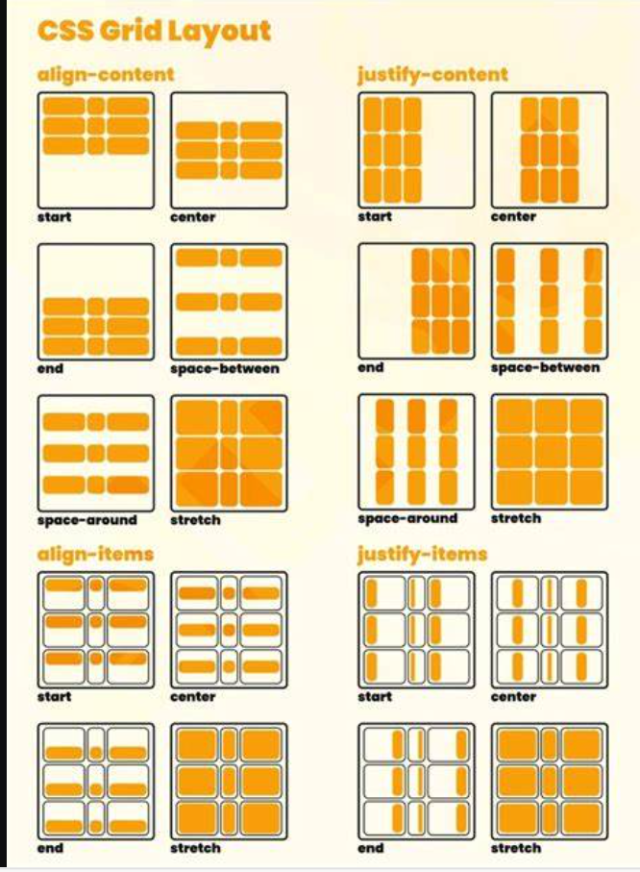

# Professional way of creating a website:-

1. Use semantic tags not divs (best for seo also)
2. In semantic tags there would be no overflows breaks etc
3. Below pic is the reference of what does semantic tags have(refer gridwebiste.html )

1. We should make the website **responsive**(not responding but showing the same screen at every type of phone or electronic devices)
2. For this we use the **media queries (aspect ratio, browser view port,**

**Flex** is used to get the thingsin **column fashion**

**Grid** is used to get the things in **row fashion**

In flex layout once the row is filled the content goes to next row(not column..flex will give column fashion but once the row is filled THEN it will go to next row

**Margin ..**is like pushing the outside content(MP)

**Padding..**is like shrinking the inside content(PS)

# DAY-23(12/08/24):-

Read about inline block..also abt sizes for avoiding jerks while shrinking the page(responsiveness)

## JavaScript:-

Java script is similar to java and c but the main thing is that till now it couldn’t run on its own ..it needs html or embed or use it along with html

But after nodejs got created we can run the javascript code directly

Interpreted is line by line execution of code

Java script is object based procedural or structural language …everything is a function

java script has no types (data types)..all types are inferred.

Inside html we write the code in <script> tag …else we can create a js file and embed into html

Similar to java even java script has Boolean which are true and false ….and 0 or non zero numbers are considered as Booleans like c

<script>

    // var k=prompt("Enter location");

    // alert(k);

    // alert(typeof(k));

    // var nu=9;

    // alert(typeof(nu));

    // var bol=true;

    // var bol2=0;

    // alert(typeof bol);

    // alert(typeof bol2);

    // //donot use the word "location" it  is keyword

    // alert(0/0);//nan..means not a valid number

    // alert(9923/0);//infinity

    // alert("10"/"10"); //will return 1

    // alert("hello"/"hello") // will return nan

    //first it will try to take a number out of the string ...if not found then it will give nan

    //data= //"true-->true"//"A10"-->true//0-->false//false-->false//true-->false //"hello" -->true//"100"--> false

    // nan==not a valid number ...therefore is nan checks if invalid or not..

    // "100" is a valid number but isNaN checks if invalid or not ..therefore false since it isvalid number

    //whereas "hello" is not a number at all...invalid number ...true for isNaN

    //alert(isNaN(data))

    //isNaN...first tries to convert the variable value to a number if converting then it will give false since isNaN is all about being invalid number...and if the conversion is not possible it will give true(since it will become invalid umber)

    //therefore isNaN is performing the typecasting

    // but the Number.isNaN is directly (no typecasting) checking if given is NaN or not is NaN true else for all cases false

    data=10

    alert(Number.isNaN(data));//returns false

    data=NaN;

    alert(Number.isNaN(data))//Returns true

    data=Number("hello")//since it cant type cast it will give NaN not true or false ..

    alert(data)//returns true ..sinc it is NaN

</script>

Javascript is like python…sometomes it doesnot need any semicolon..can keep single or double quotes for strings

Null keyword in jav or anywhere is used for dereferencing….that is not assigning to any object.

* To declare **global** scope variables we use **var**
* For **local** variables we use **let** (I,e inside the functions which we will immediately be used)
* Other than these two we also use the keyword **const..**that means once assigned we can never change them again

Document.writeln()

Console.log()

Anything that comes from world wide web is by default the string (even the numbers also)

Java has no type of method since java is purely for objects not for primitives therefore because of which it has instance of

In javascrpt “==” to return true …both type and value should be same

Errors in javascript can be seen in console …in browser..press ctrl + shift +i choose console

# Normal functions and arrow function :-

1. Both will have **let** or **const** or **var** in the left side followed by **variable** **name**
2. After that keep =
3. Now for normal functions we write

function(n){

return ;

}…the keyword **function** is important and we should keep this name only not any name

1. In arrow function, we don’t use the keyword function instead we use this ones..

(n) => {

return ;

}

# Call Back function:-

**Here we use backtick (just presssecond row first key)**

//call back functions

const isEven=(n)=>{

    return n%2==0;

};

let printMsg=(someFunction,num) => {

   const isNumEven=someFunction(num);

   console.log(`${num} is a even number : ${isNumEven}`); // here we used backtick ..second row first key

};

printMsg(isEven,18)

# DAY-24(13/08/24)

1. Typescript setup
2. Typescript file
3. Types
4. Arrays
5. Functions
6. Class

# TYPESCRIPT:-

Mixture of both java and java script(earlier js lies in html,now js can run on its own ..yes not only in browser and server ..but on its own like java ..this is just extra information)

**Set-ExecutionPolicy RemoteSigned -Scope CurrentUser** ….give this in the cmd which u r working ..to make the tsc sandbox.ts to work

In cmd type **tsc sandbox.ts** (tsc means typescript compiler ..it expects to give a type script file..it will give u a js file and THAT file is to be added in html file )

When opened js close ts file else error or red line

Html …static

Css..adds responsive

Js …adds interactivity

Type script is strict about types …not like html or js to first intialise with string then assign numbers in next line

Any change made in ts file we need to re compile again again ..using tsc sandbox.ts

Since this is difficult we do **tsc sandbox.ts -w**

(-w is watch …it is like dev tools)(no need of compiling again again)

# DAY-25(14/08/24)

# ANGULAR:-

Angular is for front end

Install node version 18 from

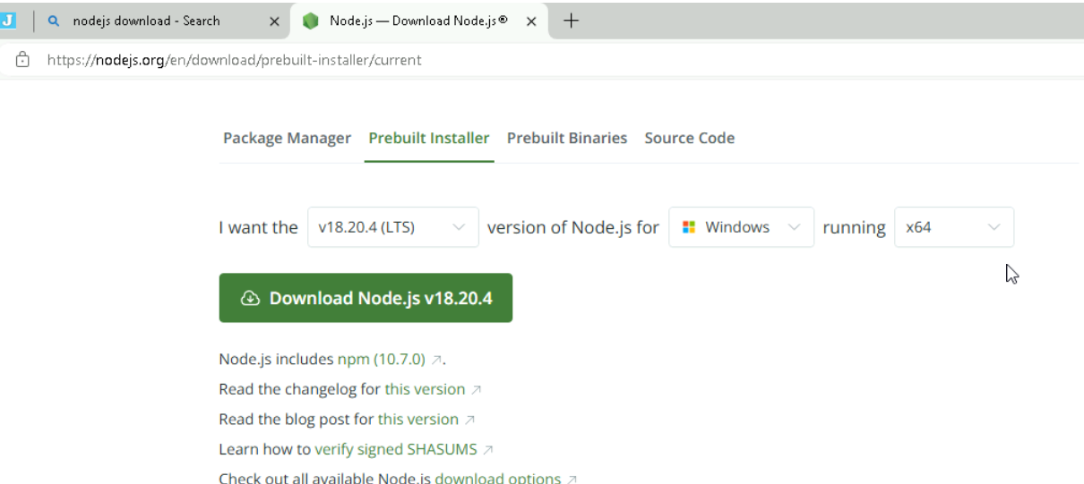

Then type 

Version 17 or 15 or any version which is compatible with nodejs

Type **ng v** (no hypen) ( to see version)

[Home • Angular](https://angular.dev/)

We use angular to build SPA(Single page Applications) …on top of that it can handle API’s very effectively.

ng new myapp …(or any name)

ng serve - -open (type in side cmd of “foldercreated” ..example inside myapp

In angular we work with or use or tell each thing as components

Binding happens between view and component

Every component have a template

Types of binding:-

1. Interpolation
2. Event binding
3. Property Binding(we use square brackets)

Architecture

* Angular js is called as angular or vice versa(IG)
* Template is not a type of binding …template and binding are separate separate
* Binding types:- 1) Interpolation 2) event 3) property 4) two way binding

//We need formsModule to make our input work

// we need commonModule for ngIf and ngFor to work

//All these are jst imported by writing the namme ...but to make it work we need to write this line in @Component{

//imports: [RouterOutlet,FormsModule,CommonModule]

//}

# DAY-26(16/08/24)

What are covered:-

1. Installation and issues
2. Architecture + history
3. How angular works when the index.html
4. Before sending the first respone angular bundles all scripts in index.html
5. Important building blocks of angular

(component,view,template,binding,directives(*ngIf,*ngFor,ngSwitchCase),services,,http,module,decorators(starts with @) )

**One tag can have only one directive ..if u want both if and for ..then we need to make sure to keep those in two different tags**

Elements of a component :-

1. Selector
2. Html file
3. CSS file
4. A class
5. Test file

Today:

1. Switch case-property binding innerhtml, ngClass

#<nameOfIdentifier> how to use a angular identifier to pass value of input element to an event handler

1. Create first user defined component and itegrate with root

**ng g c nameofcomponent**

*g=generate c=component*

To add service file ..type

**ng g s <servicename>**(type name of the service without writing the word service..example Data not DataService etc )(we should and it will generate file outside app folder only )

*g=generate s=service*

data service file is used to communicate with the external world like databases , api’s etc etc

to create model class/objects…we create our folder outside of the “app” folder in our project of angular..nothing just create outside of the “app” folder with name.ts

**// CommonModule is for to use ngfor and ngif**

# DAY-27(17/08/24)

1. Pipes
2. Bootstrap in angular
3. Forms
4. Parent child components

Best reference website for codes , api’s etc ([Angular - API List](https://v17.angular.io/api?type=pipe)) ….this has something similar to bootstrap urls ….use this links..done with pipes

**Bootstrap in angular**

* Type **npm install –save bootstap@latest** ….or any version compatible to u r angular(for me ..it is 5.3.2 version of bootstrap

Since using npm…then it will get installed everywhere in the computer from anywhere

* After that open the app ur working and goto ..
* **node_modules/bootstrap/dist/css/bootstrap.min.css** (scroll till the end )(Not only outside but inside the css folder also we have the js folder )
* **just go to Angular.json and paste the below code (but search the style tag)**
* "styles": [
* "node_modules/bootstrap/dist/css/bootstrap.min.css",
* "src/styles.css"
* ],
* "scripts": [
* "node_modules/bootstrap/dist/js/bootstrap.min.js"
* ]

Useful resource:- [26 Bootstrap Forms (freefrontend.com)](https://freefrontend.com/bootstrap-forms/)

Two types of forms:-

1. Template driven
2. Reactive forms

**Form-Group** binds the label to the input….Tracks the value and validity state of a group of form control

**Form-control** is used to tell that this element is not to be treated as normal element but to be treated as angular element…..tracks the value and validation status of an individual from control

  // the above forms module ...helps in using the “ng model”(like such attributes) inside the forms

**ngModel** …sends or binds the value to the backend or other file(I guess)

When used @Input ..the data flows from parent to child class

**-----------------------------------------Parent child …their relationship and working (learn)**

**If error is because of ngFor or ngIf …import the commonModule**

**If error is because of $event …import the component u r working on ..into the app.component**

* **Any error related to ngModel …import formsModule…**
* **Any error related to if and for ..import commonsModule…**
* **This importing should be done at both places…on top most line and in imports=[FormsModule,CommonModule ]**

[**JSONPlaceholder - Free Fake REST API (typicode.com)**](https://jsonplaceholder.typicode.com/)

It is like lorem*50 …basciallyfake data

# DAY-28(19/08/24)

1. Different kinds of forms
2. Forms validation
3. http services…i.e connecting to externalapi

<input type="text" id="name" name="name" class="form-control" required minlength="4" appForbiddenName="bob"

[(ngModel)]="hero.name" #tempnamevar="ngModel" />

* **#** **tempnamevar ="ngModel"…**it is not like we should keep # tempnamevar only ….we can keep any variable ..it is just storing the **state(whether the user has touched the field or not ..whether he entered the text or not)** of the input field…just make sure what ever the name u r giving here u should give the same here everywhere in the below code
* **name=”anything”** tag is very important to make our validations work

<div *ngIf=" tempnamevar.invalid && (tempnamevar.dirty || tempnamevar.touched)" class="alert">

<div *ngIf=" tempnamevar.errors?.['required']">Name is required.</div>

<div *ngIf=" tempnamevar.errors?.['minlength']">Name must be at least 4 characters long. </div>

<div *ngIf=" tempnamevar.errors?.['forbiddenName']"> Name cannot be Bob. </div>

</div>

By using reactive forms ..we don’t need to create model classes (example Product.ts , Login.ts etc)(Basically entity…a class which have properties)

**Form Builder:**

**Observer Design pattern: -**

**XHR request/object**

**What is observable(first find this) , observer, A ,B**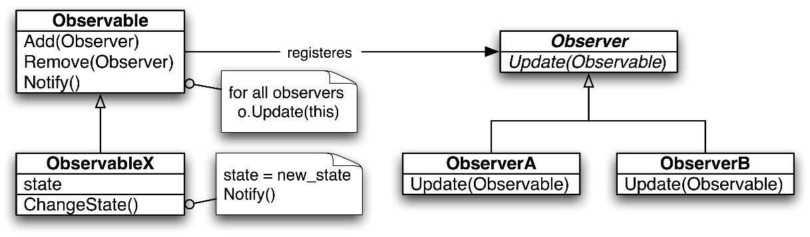

* Observer is a behavioral design pattern that enables centralized, transparent, one-way communications to a set of decoupled objects.
* It specifies communication between objects: observable and observers. An **observable is an object which notifies observers about the changes in its state.**
* The observer pattern is suitable for any scenario that requires push-based notification.
* The pattern defines a provider (also known as a subject or an observable) and zero, one, or more observers.

# DAY-29(20/08/24):-

1. promise vs observable
2. complete http methods-GET,POST,DELETE,PUT (this.http.put/post/get/delete())
3. Life cycle hooks
4. Promise:- Produces in one large chunk

Observable:- Produces in streams-small chunks

1. Promise: Produces even if there is no consumer

Observable:- Observable will produce only when there is a subscriber

1. Promise:- Communicates synchronously

Observable:- Communicates in asynchronous mode

1. Promise:- Blocks the client during communication

Observable:- Doesnot block the client and needs a callback to invoke when it completes

**Information about SUBSCRIBE :-**

// Information on subscribe....our methods return Observable objects

// Observable objects need a call back function

// the subscribe acts as a call back function

// We can say teh subscribe method acts as an entry point for our observable..

// Then we use data , error(and there associated statements) ...so that if there is an eroor it will tell us ..if not the data gets intialised and returned

// the initailization and returning is important ..so that we can sedn te message like "conform u r details" "successfully entered "

//  etc messages ...which can only be possible if something is returned

* **Make sure the variable names of backend and frontend(in everyfile)(Even in model or entity class..both in front end and backend) are same else will get error(I guess 400)**
* **Also if working with jwt keep the variable name as “password “ if kept pwd etc ..will get erro …since by default is taking variable name as “password”**

# DAY-30(21/08/24)

Topics to be covered:

1. Angular life cycle hooks – call backmethods
2. Routing
3. Karma – Testing
4. Angular files…just showed the different files in our angular app

# Angular Life Cycle Hooks:-

Resource:-

[Lifecycle of Angular components — A beginners guide | Medium](https://medium.com/@p.woltschkow/the-component-lifecycle-of-angular-easy-explained-a6283add23f4)

* Also know the difference between view and content..i guess view is what html renders and content is the information inside it …I guess index.html is view and app-component or any other user created component is content.
* Constructor is not a lifecycle method(in google every image have the constructor as a method but actually it is not) ….also it is advised that use constructor only for injection not for intialising
* Input property binding …using @Input() (we write in the child)(Evry component created is child……………app-component or index.html is parent)(In parent we write @Output()…. ) …basically taking a variable value

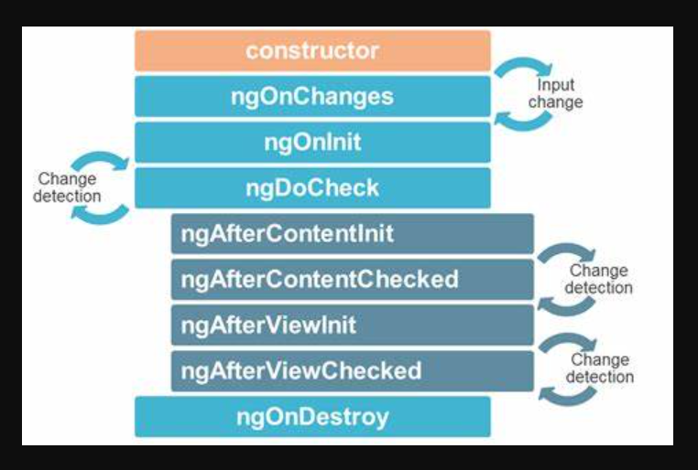

ngOnChanges is firing to child component ..not parent

**Testing:-**

* Karma is the testing server
* Jasmine is the testing framework
* Use **ng test** in the cmd of angular app
* For it to work it need chrome
* In chrome click “spec List”..to know what ad where is the error
*  it means that out of 6 test cases …5 passed 1 failed
* Each “it” should pass …were each “it” denotes a test case(u will find inside app-component.spec.ts)

[Free UML, BPMN and Agile Tutorials - Learn Step-by-Step (visual-paradigm.com)](https://www.visual-paradigm.com/tutorials/)

# DAY-31(22/08/24)

Core java features:-

1. Should have 0 or 1 package name
2. May or may not have comments
3. Import statements can be 0 or n
4. Java.lang is implicitly imported for every class
5. **Out of all type declarations only 0 or 1 can be made public not more than 1**
6. **When a type is made public the name file and the name of the public type should be same**
7. **Order:**

Package

Imports

Comments

Type declarations (class, interfaces, enum , record)

1. Now after the class …we

Write data members ..static or non static (state)

1. Anonymous blocks
2. Auxiliary methods - constructors
3. Mutators-accessor – set/get provide public interface to private data
4. Member methods-static and non static
5. Nested classes interfaces enums and records
6. Classes can be declared in a class, in a method in a loop,

**Anonymous classes:-** Installation of an interface without implementing the interface…very helpful when we are writing lambda.

Runnable r =new Runnable(){

Public void run(){

System.out.println(“From run method”);

}}

But right now this method(or this approach) is discontinued …now we should do this using functional interface.

Now we write code in this way:-

Runnable r1=()->{

System.out.println(“From run method”);

};

r1.run();  
}

**Literal:-** actual type supported by language (different for different programing languages)..they are also known as constant representation of a value supported by a language.

**Literals in general.**. more will be there in every language….

**Char c=65 .**.is a valid literal and char c=-65 is invalid literal

Integer, real, true, false, character(keyboard keys),\n,\t,\b,\f, null

**Identifier:-** it is a name given to a variable, method, class or type definitions

**Expressions:**- It is the combination of operators and operands

**Operands:**- literal, constant, variable and method call

Example:- Math.pow(2,2)+Math.max(10,20)-600

….any modern code written after java 8 we see..**function,predicate,supplier, and consumer (learn them )**

**Example:**

**Function<String,String> …etc**

**Learn streams…**

**Process of streams:-**

1. **First convert into streams**
2. **Then apply the map function ( I guess)**
3. **Then use ____ function( don’t know the name)(for example..collect)**

[**API Reference • Overview • Angular**](https://angular.dev/api)

[**CommonModule • Angular**](https://angular.dev/api/common/CommonModule)

**Angular (Notes):-**

1. Model === component-class.ts file ; View===html of the component
2. **Two-way Data Binding** in Angular allows you to automatically synchronize data between a component class property (property of a component class) and an input element (e.g., an input field) in your template.
3. To achieve this binding, it’s typically used with Angular *[(ngModel)]*directive. This is basically the combination of the **Property Binding** & the **Event Binding**, which helps to communicate in a two-way manner between the property in the component and a user interface element, such as an input field.
4. **Two-way binding** means, that whatever value we may enter from the front end, it will be automatically bound to the variable in the typescript file.

**Example code:-**

<!-- app.component.html -->

<h2 style="color: green">

GeeksforGeeks

</h2>

<h2>

How to Achive Two-Way Data

Binding in Angular with ngModel ?

</h2>

<input [(ngModel)]="message"

placeholder="Enter your message" />

<p> You entered:

<b style="color: green;">

{{ message }}

</b> </p>

**Explanation**:- whatever the input field is taking we are storing inside the variable named “message”

BRD(business req doc)

Use external api or create u r own with ur own data

Not one or 2 func but many